Data Analytics on the Web

Dr Russell Hunter, Ian Turnbull and

Dr Susan Murray

Course Structure

1. Before starting the course, go to Tutorial 0 in the tutorial folder in Brightspace and complete it.
2. Part 1: Data Science and Big Data Analytics: An overview

What you will learn: Some theory about the background of Data Science and Big Data including some definitions of the Data Analytics Lifecycle.

1. Part 2: Using R for Data Analytics

What you will learn: Basics about R that will be specifically very useful throughout the course and a nice investigation into creating a linear regression model with R. Note, we will be using Google Colab with an R kernel for this part of the course.

1. Part 3: Machine Learning: An Overview

What you will learn: Theory about machine learning with some basic introductions to Tensorflow.

1. Part 4: A Hands-on approach to Machine Learning

What you will learn: An in-depth investigation into the California Housing Problem for predicting house prices using R and Tensorflow. This will be done over two separate colab sheets. One with an R kernel and the other with python.

1. Part 5: Neural Networks

What you will learn: An overview of neural networks and Deep Learning Neural Networks, highlighting important features, such as architecture, learning algorithms and hyper-parameters.

1. Part 6: Tutorial Set
2. Tutorial 0 – Setting up a google account.
3. Tutorial 1 – Get the data.
4. Tutorial 2 – Data Analysis
5. Tutorial 3 – Tensorflow and linear regressor
6. Tutorial 4 – Tensorflow and DNN regressor

Appendix A

**Part 1: Data Science and Big Data Analytics: An overview**

1. Introduction

There is a huge buzz in the industry about Big Data and the need for advanced analytics. With the likes of Facebook, Google and others producing ever increasing amounts of data and the availability of new data sources have created a need to rethink existing data structures to enable analytics that take advantage of Big Data.

1.1 Big Data

In the modern world, data is created all the time and at an ever-increasing rate. Social media with billions of users, imaging technologies for medical diagnosis, the Large Synoptic Survey Telescope will gather 30TB per night and don’t forget our smart phones and smart watches etc. that are all linked and generate diagnostic information that needs to be stored and processed in real-time. Keeping up with the data is difficult, but analysing it is even more difficult. With the rise of the Internet of Things and non-standard data structures this becomes even more difficult when trying to identify meaningful patterns and extract useful information. These challenges of the data deluge present the opportunity to transform government, business, science and every life, I am very lucky to work in an office that uses this information to make exciting new findings and products.

Here are some examples of the types of places leading the field in gathering and exploiting data:

-  Credit card companies monitor every purchase made and can identify fraudulent purchases with a high degree of accuracy using rules derived from billions of transactions.

-  Mobile phone companies analyse calling patterns to offer incentives about staying on their network.

-  LinkedIn and Facebook’s primary product is data. The valuations of these companies are heavily derived from the data they gather and host.

Big Data can be defined by these three main attributes:

-  Huge volume of data (billions of rows and millions of columns)

-  Complexity of data types and structures

-  Speed of new data creation and growth (Big Data can describe high velocity data, with rapid data ingestion and near real time analysis)

Volume is often the most talked about in terms of Big Data, but the variety and velocity provide a better definition. In fact, Big Data is often described as having 3 Vs: Volume, Variety and Velocity.

There are additional ‘V’ properties used to describe Big Data, with some authors suggesting as many as 10. However, there is one particular additional property that can have some significant impact upon how Big Data is considered and handled. This is *Veracity*, which describes the overall ‘Truthfulness, accuracy, or correctness’ of data. A reduction in veracity can be introduced in many different ways, such as by *noise* in vehicle automation sensor systems, data errors or manipulation in IoT networks, or even more serious ethical considerations such as racial bias in facial recognition or the potential of bias in historical police data. However, the errors in Veracity are introduced, careful consideration of these possibilities will help provide a better understanding of the reliability and usefulness of any analytics activity.

Big Data has brought about the need for organisations to develop new data architectures (like Facebooks TAO) and analytic sandboxes (Google’s Data Lab), new tools, new analytic methods, and an integration of multiple skills into the role of the data scientist.

Despite the flood of data that has grown exponentially because of mobile sensors, social media, medical imaging etc., the cost to perform work on it has fallen by an order of magnitude of 3 (at least) and the cost continues to drop as technology advances.

1.1.1 Data Structures

Big Data can come in multiple forms, including structured and varying degrees of non-structured data (for example, images, videos, financial data, text files etc.). Traditional data analysis performed by organisations was done primarily on structured data, but with Big Data, most of the data is unstructured or semi-structured which requires different tools and techniques to process and analyse. Distributed computing environments and massively parallel processing architectures are the preferred approach to process such complex data.

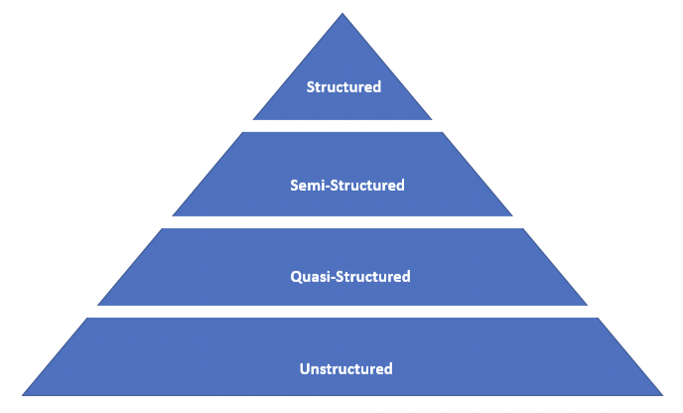

Around 90% of future data growth will come from non-structured data types. Although they are all different, they are often mixed. As an example, a relational database management system may store call logs for a software support company, this is likely to be structured (i.e. time-stamps, problem- type etc.) but also, there may be free-form call log information taken from an email request for support or transcript of the call or even an audio file of the call. Many insights can be extracted from the non-structured data.

a)  Structured data: like a traditional RDBMS table, spreadsheet or a CSV (we will be using a couple of these)

b)  Semi-structured: Text data files that contain XML for example

c)  Quasi-structured: Text data with erratic data formats that can be formatted with effort and time

d)  Unstructured data: Data that has no inherent structure (text document, PDFs, images and video)

1.1.2 Data Repositories

In the past, people tended to use spreadsheets, this is fine when everything is small and local, but it does mean that changes are likely to occur over different instances. This moves us on to Data Warehouses which are run by IT and Data Administrators (and puts an analyst at their mercy in many ways). Now, there are massive cloud-based repositories and tools (see https://cloud.google.com/bigquery/docs/)

1.2 State of the Analytics Practice.

Current business problems have led organisations to become more analytical and data-driven.

Businesses may want to optimise their operations (sales, pricing, profitability and efficiency), identify risk (customer churn, fraud and default), predict new opportunities (upsell, cross-sell, best new customer prospects) and comply with laws or regulations (anti-money laundering, fair lending etc.)

1.2.1 Business Intelligence vs. Data Science

Business Intelligence (BI) tends to provide reports and queries on business questions for the current period or in the past. BI provides hindsight, some insight, and generally answers questions related to ‘where’ and ‘when’ events occurred.

Data Science tends to use disaggregated data in a more exploratory and forward focussed way, focusing on analysing the present and enabling informed decisions about the future. So a data scientist might tend to look at forecasting and be more exploratory whilst using optimisation (for example) to deal with more open-ended questions. This approach provides insight into current activity and foresight into future events, while generally focusing on questions related to ‘why’ and ‘how’ events occur.

BI problems tend to require highly structured data organised in rows and columns, Data Science projects tend to use many types of data sources, including large or unconventional datasets.

For example:

Business Intelligence would use the following techniques and data types (typically); Standard and ad hoc reporting, queries, details on demand and; Structured data, traditional resources and manageable datasets. Common questions they may ask are; What happened last quarter? How many units sold? Where is the problem? In which situations?

Data Science would use the following techniques and data types (typically); Optimisation, predictive modelling, forecasting, statistical analysis and; Structured and un-structured data, many types of sources, very large datasets. Common questions they may ask are; What if..? What’s the optimal scenario for our business? What will happen next? What if these trends continue? Why is this happening?

1.3 What has led to the surge in Big Data?

The figure below shows the trends in data creation over time:

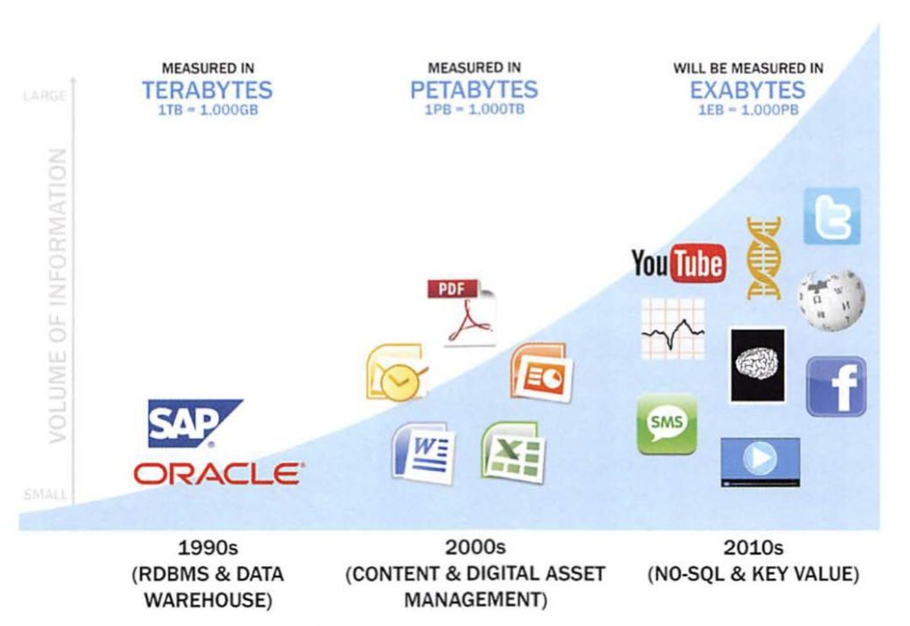

So, as we stated earlier, the Big Data trend is generating an enormous amount of information from many new sources. This data flood requires advanced analytics and new market players to take advantage of these opportunities and new market dynamics. Data collectors and organisations are realising that the data they can gather from individuals contains intrinsic values and because of this, a new digital economy has emerged, and it is still evolving.

-  Data Devices and the Internet of Things: gather data from multiple locations and continuously generate new data about this data. For each GB of new data created, an additional petabyte of data is created about that data.

-  Data Collectors: include sample entities that collect data from the device and users

-  Data aggregators: make sense of the data collected from the various entities from the “Internet of Things.” These organisations compile data from the devices and usage patterns collected by government agencies, retailers and websites. In turn, they can choose to transform and package the data as products to sell to brokers, who may want to generate marketing lists of people who may be good targets for specific ad campaigns.

-  Data users and buyers: these groups directly benefit from the data collected and aggregated by others within the data value chain.

Because of this upsurge, Big Data and Data Science is one of the hottest areas in the computing sector at the moment.

A typical Data Scientist will have 3 recurring sets of activities:

-  Reframe business challenges as analytics challenges

-  Design, implement and deploy statistical models and data mining techniques on Big Data

-  Develop insights that lead to actionable recommendations

A Data Scientist will have 5 main sets of skills and behavioural characteristics:

-  Quantitative skills, such as mathematics or statistics

-  Technical aptitude i.e. software engineering, machine learning, and programming skills

-  Critical thinking, it is important that data scientists can examine their own work critically

-  Curious and creative, data scientists are passionate about data and finding creative ways to solve problems and portray information

-  Communicative and collaborative, data scientists must be able to articulate the business value in a clear way and collaboratively work with other groups

1.4 Example of Big Data Analytics

Big Data presents a lot of opportunities to improve sales and marketing analytics and a retailer in America, called Target, are very good at this. They use Big Data to drive new revenue. Target analyse consumer-purchasing behaviour where Target’s statisticians determined that the retailer made a great deal of money from three life-event situations:

-  Marriage

-  Divorce

-  Pregnancy

The most profitable of these events is pregnancy and the famous case where they were able to determine a woman was pregnant and send advertising to her house before her family knew. This kind of knowledge allowed them to offer specific coupons and incentives. They are also able to determine what month of pregnancy the woman is in! This allows them to manage their inventory, knowing there would be a demand for specific products and how this would change over time.

Here is a nice supplementary video: https://www.youtube.com/watch?v=bu1dDLMHHw8

We know that Data Science projects differ from most traditional BI projects and many data analysis projects in that data science projects are more exploratory in nature. Therefore, we must have a process to govern them and ensure that the participants are thorough and rigorous in their approach.

Problems that appear very big and daunting can be broken down into smaller pieces or actionable phases. Having a solid process ensures a comprehensive and repeatable method for conducting analysis. Additionally, it helps focus time and energy early in the process to get a clear grasp of the problem to be solved.

A common mistake is rushing into data collection and analysis. It is useful to spend sufficient time to plan and scope the amount of work involved, understanding requirements, or even framing the problem properly. Also, it may become apparent midway that the project sponsors are trying to achieve an objective that may not match the available data or that they are attempting to address an interest that differs from what had been explicitly communicated. If this happens, we must revert to the initial phases of the process or cancel the project.

Creating and documenting a process helps demonstrate rigour, which provides additional credibility to the project. A well-defined process also offers a common framework for others to adopt, so the methods can be repeated in the future or when/if others join the team.

1.5 Data Analytics Lifecycle

In 2012, Harvard Business Review featured an article title “Data Scientist: The Sexiest Job of the 21st Century”. Here is an example of seven roles for a successful analytics project (some of these roles may be done by one person).

-  Business User: Someone who understands the domain area and usually benefits from the results. Usually a business analyst, line manager, or deep subject matter expert in the project domain fulfils this role.

-  Project Sponsor: Responsible for the genesis of the project. This person sets the priorities for the project and clarifies the desired output.

-  Project Manager: Ensures that key milestones and objectives are met on time and at the expected quality.

-  Business Intelligence Analyst: Provides business domain expertise based on a deep understanding of the data, key performance indicators (KPIs), key metrics, and business intelligence from a reporting perspective. Business Intelligence Analysts generally create dashboards and reports and have knowledge of the data feeds and sources.

-  Database Administrator: Provisions and configures the database environment to support the analytics needs of the working team. These responsibilities may include providing access to key databases or tables and ensuring the appropriate security levels are in place related to the data repositories.

-  Data Engineer: Leverages deep technical skills to assist with tuning SQL queries for data management and data extraction and provides support for data ingestion into the analytic sandbox. The data engineer works closely with the data scientist to help shape data in the right ways for analyses.

- Data Scientist: Provides subject matter expertise for analytical techniques, data modelling, and applying valid analytical techniques to given business problems. Designs and executes analytical methods and approaches with the data available to the project.

Here is a diagram showing the different stages of the Data Analytics Lifecycle:

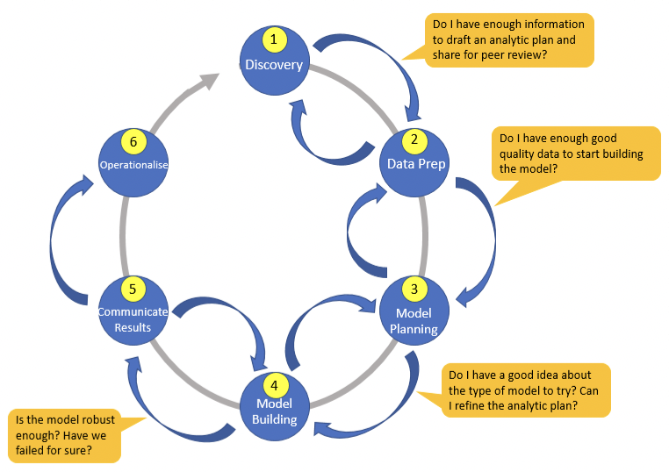

Here is a brief overview of the main phases:

-  Phase 1 – Discovery: At this phase, the team learns the business domain, including relevant history i.e. whether something similar has been done in the past that they can learn from. The team assesses the resources available to support the project in terms of people, technology, time and data. An important activity here is framing the business problem as an analytics challenge such as formulating initial hypotheses to test and begin learning the data.

-  Phase 2 – Data preparation: This phase requires an analytic sandbox, in which the team can work with the data and perform analytics for the duration of the project. So, they need to extract, load and transform into the sandbox. At this phase, the team needs to familiarise itself with the data thoroughly and take steps to condition the data.

-  Phase 3 – Model planning: At this phase the team determines the methods, techniques and workflow it intends to follow for the next model building phase. The team explores the data to learn about the relationships between variables and subsequently selects key variables and the most suitable models.

-  Phase 4 – Model building: At this phase, the team should develop datasets for testing, training and production purposes. In addition, in this phase the team builds and executes models based on the work done in the model planning phase.

-  Phase 5 – Communicate results: The team, in collaboration with the stakeholders, determines whether the project is a success, or a failure based on the criteria developed in Phase 1. The team should identify key findings, quantify the business value, and develop a narrative to summarise and convey findings to stakeholders.

-  Phase 6 – Operationalise: Here, the team delivers final reports, briefings, code and technical documents. The team may run a pilot project to implement the models in a production environment.

Each of these phases are very important but some are outside the scope of this module, we will touch on a few of these again, but we will mainly be focussing on a particular set of skills:

-  Obtaining the data

-  Getting it in the correct form

-  Analysing the data using R

-  Cleaning the data

-  Creating a Model

-  Training a Deep Learning Neural Network and a Linear Regressor

-  Analysing the results

**Part 2: Using R for Data Analytics**

This section will take you through the basics of data analytics using the open access programming software R.

These are the main steps that we will be going through:

1. Familiarising yourself with the R package.
2. Get the data.
3. Discover and visualise the data to gain insights.
4. Prepare the data for Machine Learning algorithms.
5. Select a model and train it.

2.1 An introduction to R

R is a free of charge programming language and software package for statistical analysis and graphics. It provides a wider range of analytical and graphical commands than any other software.

Despite being a free package there is a lot of useful tech support and literature available to help users of all levels.

Note: Comments in R are preceded by #. It is conventional for a double hash '##' to precede comments. Comments can also be placed after a command. The convention here is to use a single #. I suggest using a lot of comments – the annotation is invaluable to future work and especially with collaboration.

Another thing to note is that R uses Unix convention of forward slashes (you cannot use backslashes when specifying a file path). You will also need to use quotation marks "" (as it is a string of text).

1. You should be logged into your newly made Google account and you should go to Google Colab (<https://colab.research.google.com/>).

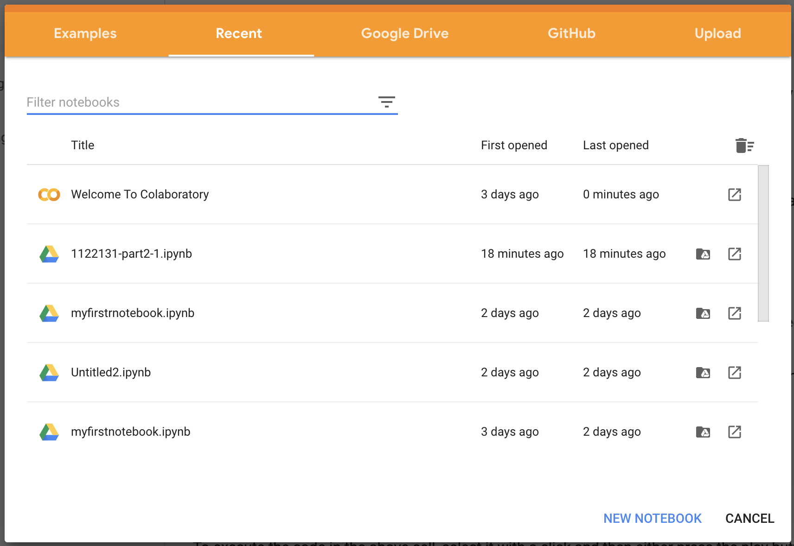

1. This will likely look different on yours. Click on the GitHub tab:

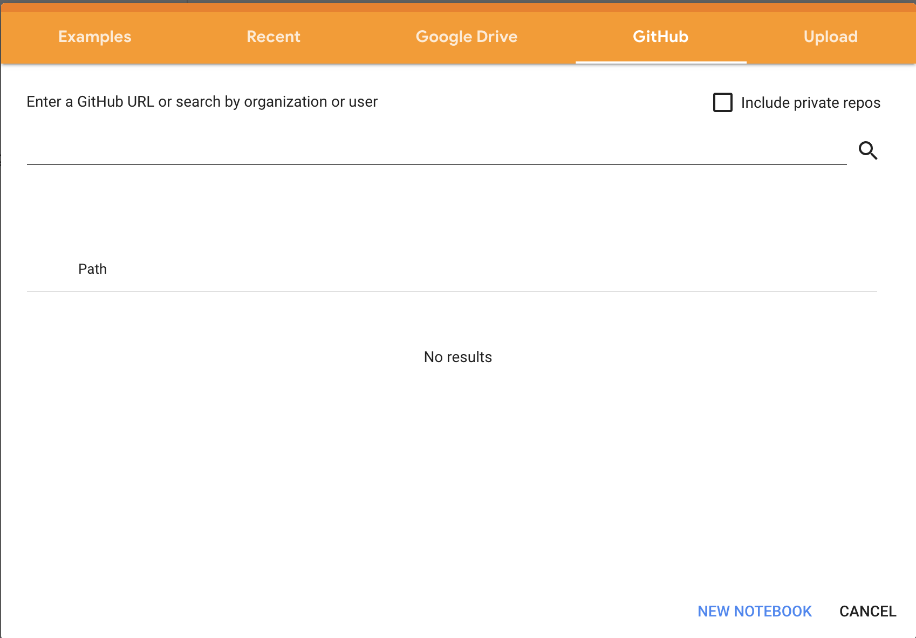

1. Add the url: <https://github.com/1122131uhi/dataAnalytics/blob/master/part2_2_1a.ipynb>

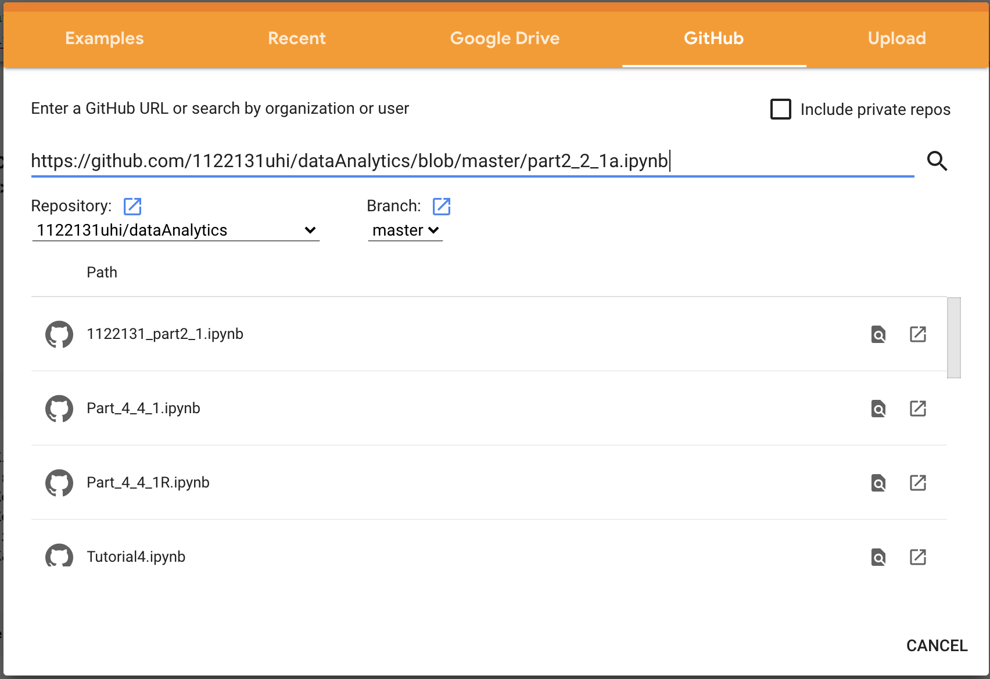

1. Click the search icon (magnifying glass):



1. You should now have the Colab file, try saving a change to the code box:

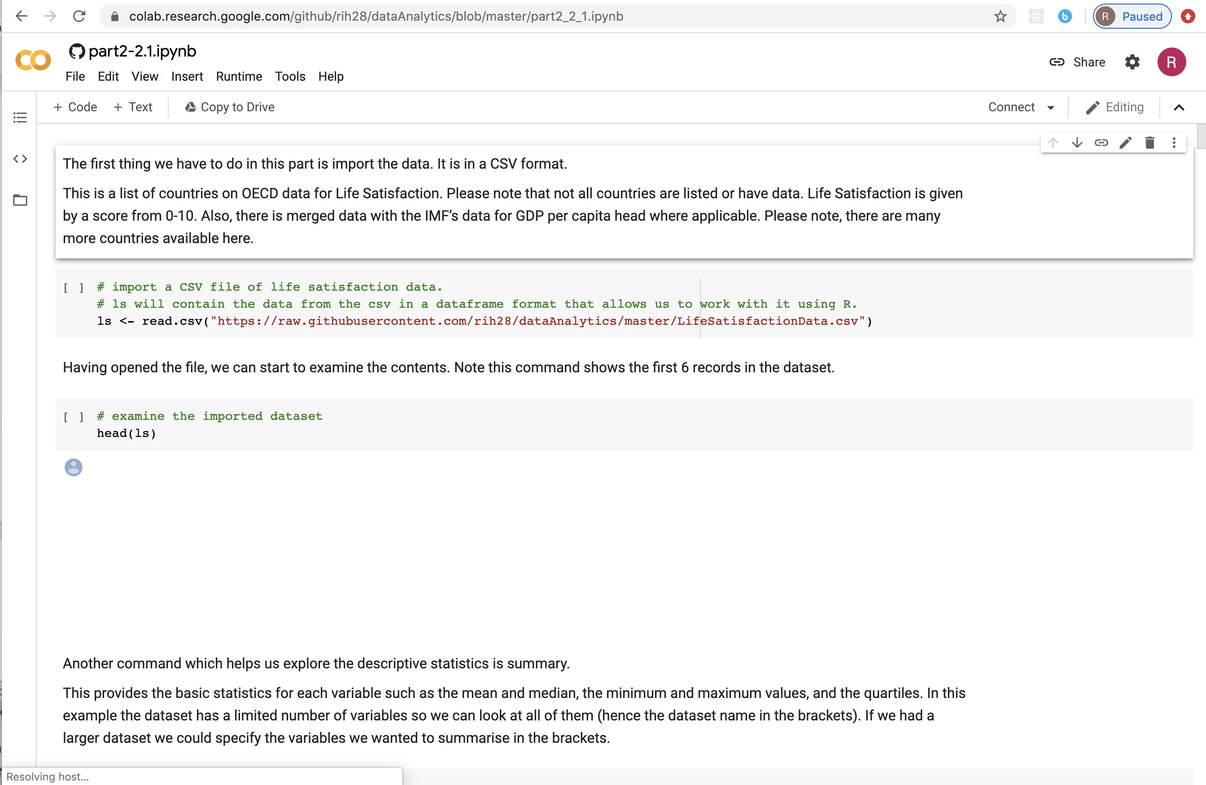

1. Save a copy in your local drive:

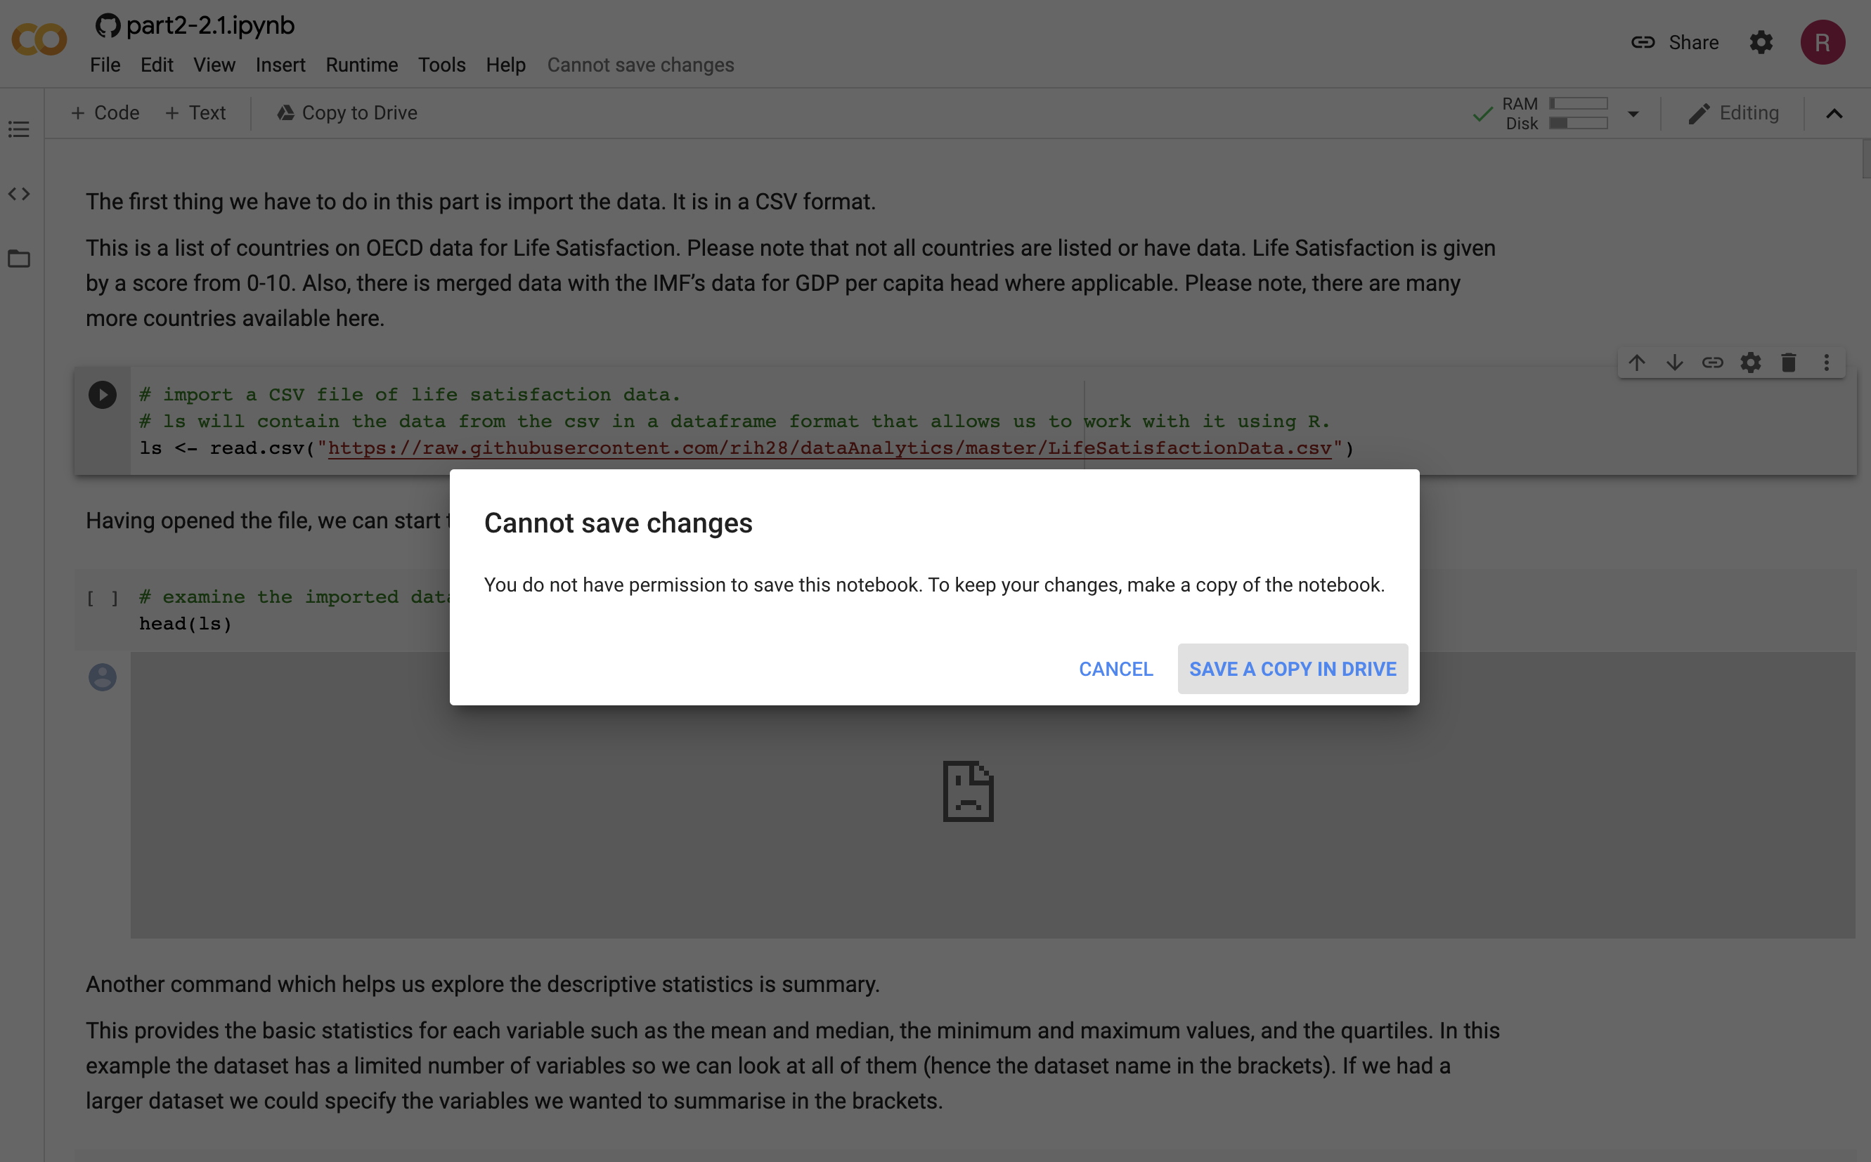

1. Open your local file in a new tab:

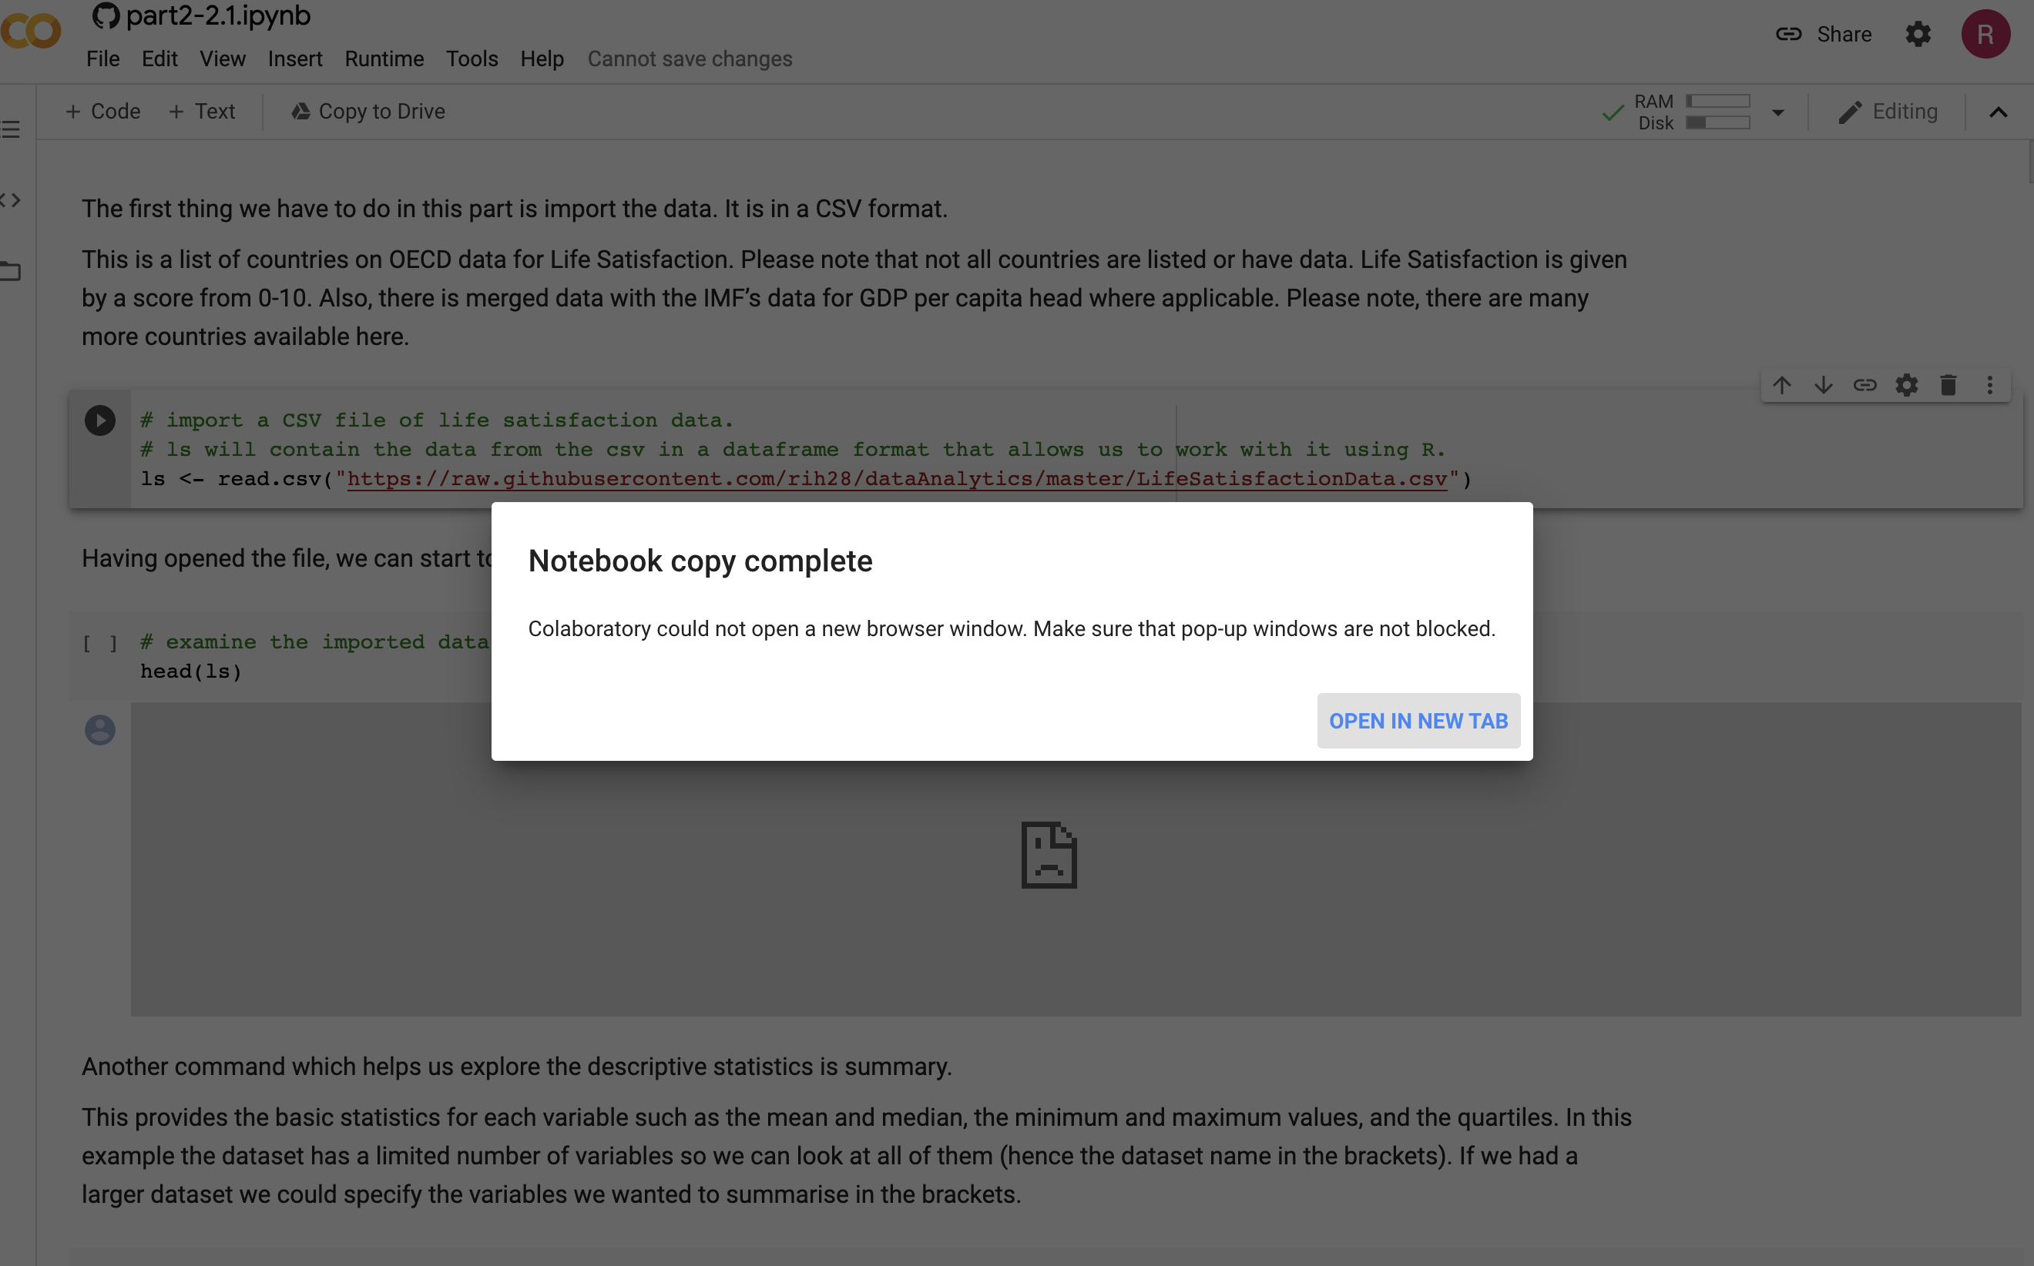

1. Now, just go through the workbook (in the new tab) and click on the code box play buttons starting from the top down. You should wait until the spinner on the button stops after pressing:



1. You might get a warning that this is not authored by Google. Click Use Anyway! Now you should have something like this:

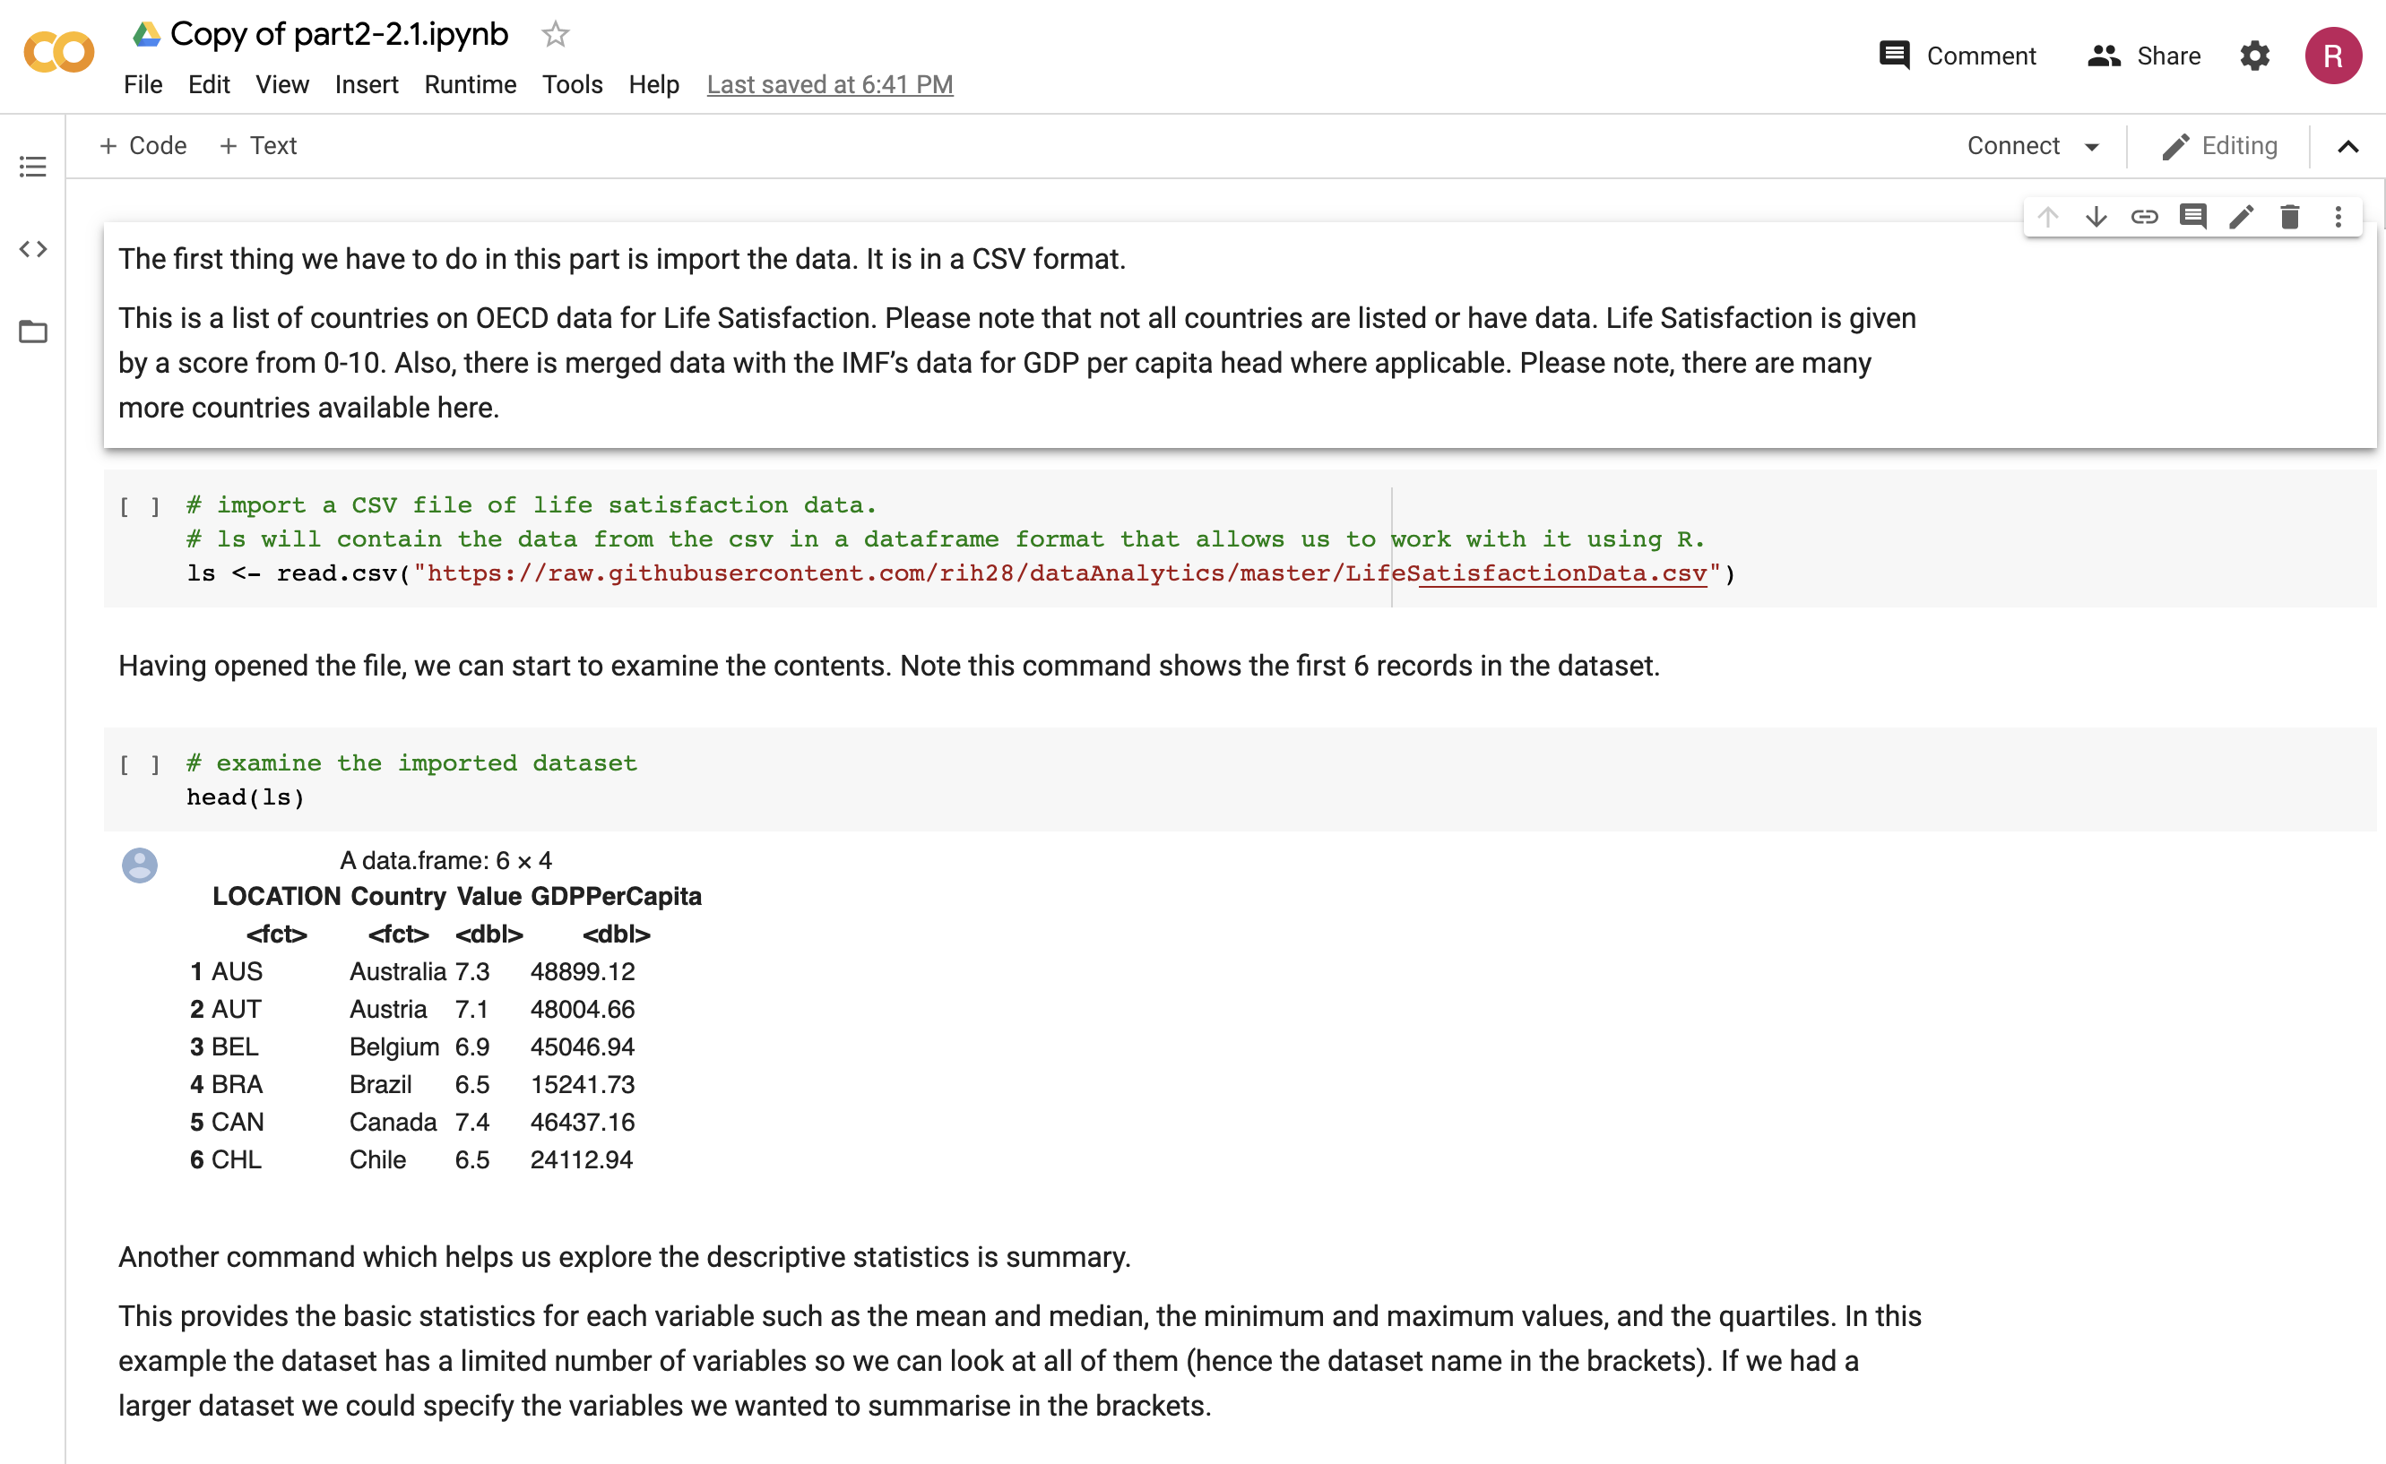

Now, unlike the last part of this document, the rest of this chapter is done in the google sheet. Remember, all you have to do is click on the code cells and run the little play button at the start:



The text cells are just for reading.

**Remember to save your file regularly (File>Save).**

You should see this, if everything is up to date:



2.2 Linear Regression

Similar to the last subsection, we will use a google colab sheet. You can follow the same process as above with the following URL: <https://github.com/1122131uhi/dataAnalytics/blob/master/part2_2_2a.ipynb>

**Part 3. Machine Learning: An Overview**

3.0 Introduction

The field of computer science is buzzing about Machine Learning (ML) and the boundless possibilities that these optimised algorithms and super-fast machines can give benefit to business, science and other areas. However, ML has been around for a very long time and has been working well for decades with common applications such as Optical Character Recognition or Spam filters and has since grown to give us better recommendations or voice search for example.

Machine learning is the “field of study that gives computers the ability to learn without being explicitly programmed” (Samuel, A., 1959)

But a more direct definition would be “A computer program is said to learn from experience E with respect to some task T and some performance measure P, if its performance on T, as measured by P, improves with experience E,” (Mitchel, T., 1997)

Using a spam filter as an example of ML, we can say that the spam filter has learnt to flag spam by being given examples of spam emails and examples of non-spam emails. The examples used in training are known as a training set and each training example is called a training instance. So, with reference to the direct definition above, the task T is to flag spam for new emails, the experience E is the training data, and the performance measure P needs to be defined. In this case, we can use the ratio of correctly classified emails. This performance measure is called accuracy and it is used in classification tasks (which we will learn more about later).

Why can’t I just write a program with if statements? (I hear you ask). If you use a standard approach, like checking for known words or phrases that come up a lot in the subject and patterns in the sender’s name or the email body and so on and write a detection algorithm for each of the patterns, it will work rather well to start with (with a bit of testing and adjustment). However, the problem is non-trivial, it will likely become a long list of complex rules and then very difficult to maintain. In contrast, ML techniques automatically learns the patterns based upon comparison with good emails. The program is shorter, more accurate and easier to maintain. A good point is that people who spam will evolve their techniques to try and beat the filters. ML approaches handle this easily (and automatically) whereas using a hand-coded version, you would need to write new rules as spammers evolve.

Therefore, ML is very useful for problems that are too complex for traditional algorithms or have no known algorithm. An example is speech recognition (just think about the number of languages and millions of different ways to say things).

We can also inspect ML algorithms to see what they have learned. We can see what a trained spam filter has for predictors of spam and use this to learn more about the problem. This is not easy in all tasks, but in more complex problems this can reveal unsuspected correlations or new trends, and thereby lead to a better understanding of the problem. This is called data mining and is used to dig into large amounts of data to help discover patterns that were not immediately clear.

3.1 Types of Machine Learning Systems

There are many different type of ML systems and we can classify them in broad categories based on the following:

-  Whether or not they are trained with human supervision (supervised, unsupervised, semi- supervised, and Reinforcement Learning)

-  Whether or not they can learn incrementally on the fly (online versus batch learning)

-  Whether they work by simply comparing new data points to known data points, or instead detect patterns in the training data and build a predictive model (i.e. instance-based vs. model- based learning)

The criteria above can be combined in many different ways. For example, a spam filter may learn on the fly using a deep neural network model trained using examples of spam and non-spam; this makes it an online, model-based, supervised learning system.

3.1.1 Supervised/Unsupervised Learning

ML systems can be classified according to the amount and type of supervision they get during training. There are 4 main categories: supervised, unsupervised, semi-supervised and reinforcement learning.

3.1.1.1 Supervised learning

In supervised learning, the training data you feed to the algorithm includes the desired solutions, called labels.

A typical supervised learning task is classification (see the neural networks section for some work you can do yourself and make a cool classifier with TensorFlow). We will learn more about this later,

however, the spam filter is a good example of this: It is trained with many example emails along with their class (spam or non-spam), and it must learn how to classify new emails.

Another typical task, one which you will be doing for the assignment, is to predict a target numeric value, such as the price of a car, given a set of features (mileage, age, and so on.) called predictors. This sort of task is called regression and is something we have and will be concentrating on in this course. To train the system, you need to give it many examples of cars, including both their predictors and their labels (i.e., their prices).

We should note that in ML an attribute is a data type (i.e. “Mileage”), while a feature has several meanings depending on the context, but generally means an attribute and its value (for example “Mileage = 10,000”). It is common to use these words interchangeably.

Note that some regression algorithms can be used for classification and vice versa. For example, Logistic Regression is commonly used for classification, as it can output a value that corresponds to the probability of belonging to a given class (e.g., 25% chance of being spam).

Here are some of the more commonly used supervised learning algorithms:

-  k-Nearest Neighbours

-  Linear Regression (we will be using this in the tutorials and assignments)

-  Logistic Regression

-  Support Vector Machines (SVMs)

-  Decision Trees and Random Forests

-  Neural networks (we will be using a Deep Neural Network in the tutorials and assignments)

3.1.1.2 Unsupervised learning

In unsupervised learning, the training data is unlabelled. The system tries to learn without a teacher. Here are some of the most common unsupervised learning algorithms

a) Clustering

-  k-Means

-  Hierarchical Cluster Analysis

-  Expectation Maximisation

b) Visualisation and dimensionality reduction

-  Principal Component Analysis

-  Kernel PCA

-  Locally-Linear Embedding

-  t-distributed Stochastic Neighbour Embedding

c) Association rule learning

- Apriori

- Eclat

Let’s say you have a blog and that you have a lot of data about its visitors. You can run a clustering algorithm to try to detect groups of similar visitors. You don’t tell the algorithm which group a visitor belongs to, it finds those connections by itself.

For example, it might notice that 40% of your visitors are males who love comic books and generally read your blog in the evening, while 20% are young sci-fi lovers who visit during the weekends, and so on. If you use a hierarchical clustering algorithm, it may also subdivide each group into smaller groups. This may help you target your posts for each group.

Visualisation algorithms are also good examples of unsupervised learning algorithms: you feed them a lot of complex and unlabelled data, and they output a 2D or 3D representation of your data that can easily be plotted (see figure below).

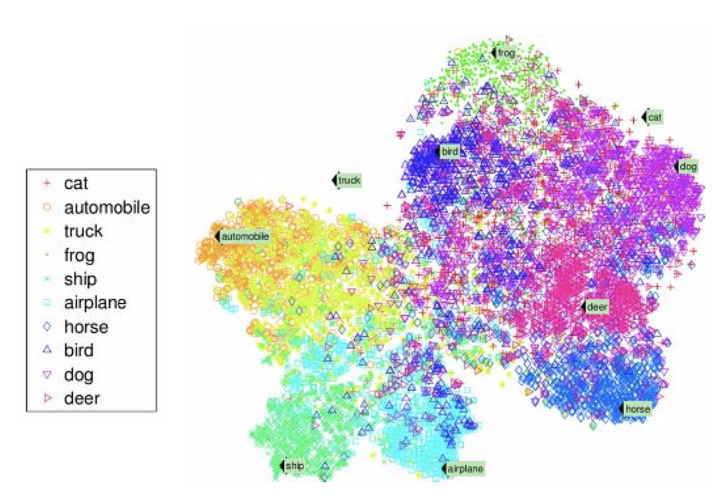

The algorithms try to preserve as much structure as they can (for example, trying to keep separate clusters in the input space from overlapping in the visualisation), so you can understand how the data is organised and perhaps identify unsuspected patterns.

A related task is dimensionality reduction, in which the goal is to simplify the data without losing too much information. One way to do this is to merge several correlated features into one. For example, a cars mileage may be very correlated with its age, so the dimensionality reduction algorithm will merge them into one feature that represents the cars wear and tear. This is called feature extraction

An important unsupervised task is anomaly detection. For example, detecting unusual credit card transactions to prevent fraud, catching manufacturing defects, or automatically removing outliers from a dataset before feeding it to another learning algorithm. The system is trained with normal instances, and when it sees a new instance it can tell whether it looks like a normal one or whether it is likely an anomaly.

Another common unsupervised task is association rule learning, in which the goal is to dig into large amounts of data and discover interesting relations between attributes. For example, suppose you own a supermarket. Running an association rule on your sales logs may reveal that people who purchase barbecue sauce and crisps also tend to buy steak. Thus, you may want to place these items close to each other.

Here are some supplementary lectures on this topic:

https://www.youtube.com/watch?v=h0e2HAPTGF4 https://www.youtube.com/watch?v=esmzYhuFnds https://www.youtube.com/watch?v=eg8DJYwdMyg

3.1.1.3 Semi-supervised learning

Some algorithms can deal with partially labelled training data, usually a lot of unlabelled data and a little bit of labelled data. This is called semi-supervised learning.

Google photos is a good example of this, in that it can detect a person A in some photos then another person B in some other photos. Once you define who these people are i.e. one label per person, it will be able to name everyone in every photo. Useful for searching photos.

Most semi-supervised learning algorithms are combinations of unsupervised and supervised algorithms. For example, deep belief networks are based on unsupervised components called restricted Boltzmann machines stacked on top of one another.

3.1.1.4 Reinforcement Learning

Reinforcement Learning is quite different. The learning system, called an agent in this context, can observe the environment, select and perform actions in this context, can observe the environment, select and perform actions, and get rewards in return (or penalties in the form of negative rewards, like touching something hot). It must learn by itself what the best strategy is, called a policy, to get the most reward over time. A policy defines what action the agent should choose when it is in a given situation.

3.1.2 Batch and Online Learning

Another criterion used to classify ML systems is whether or not the system can learn incrementally from a stream of incoming data.

3.1.2.1 Batch Learning

In batch learning, the system is incapable of learning incrementally (i.e. it must be trained using all the available data). This will generally take a lot of time and computing resources, so it is normally done offline. Firstly, the system is trained, and then it is launched into production and runs without learning anymore; it just applies what it has learned. This is called offline learning. If you want a batch learning system to know about new data (i.e. new spam), you need to train a new version of the system from scratch on the full dataset (not just new, but also the old data), then stop the old system and replace it with a new one.

The whole process of training, evaluating and launching a ML system can be automated fairly easily, so even a batch learning system can adapt to change. Simply update the data and train a new version of the system from scratch as often as needed (we will be re-training models later in tutorials and in the assignment).

This solution is simple and works fine, but training can take a long time, so it is not good for rapidly changing data (i.e. predicting stock prices), then you need a more reactive solution.

Some major problems:

Training full set of data takes lots of computing resources. If you have to train from scratch every day, it will end up costing a lot. If the amount of data is huge, it may be impossible to use a batch learning algorithm.

For things like smartphones, which needs to learn autonomously and has limited resources, carrying around large amounts of training data and taking up a lot of resources to train for hours would not be good. Thankfully we have online learning.

3.1.2.2 Online Learning

Online learning is where we train the system incrementally by feeding it data instances sequentially, either individually or by small groups called mini-batches. Each learning step is fast and cheap, so the system can learn about new data as it gets it.

Online learning is great for systems that receive data as a continuous flow, and need to adapt to change quickly and autonomously. It is also good when you have limited computing resources. So, once an online system has learned about new data instances, it does not need them anymore, so you can discard them. This can save lots of disk space.

Online learning algorithms can also be used to train systems on huge datasets that cannot fit in one machines main memory. The algorithm loads part of the data, runs a training step on that data, and repeats the process until it has run on all of the data.

As a side note, the whole process is usually done offline (wait, isn’t this online I hear you say!?!). It should be thought of as incremental learning.

An important parameter of online learning systems is how fast they should adapt to changing data, this is known as the learning rate. If you set a high learning rate, then your system will rapidly adapt to new data, but it will tend to quickly forget the old data (which is bad for spam filters). On the other hand, if you set a low learning rate, the system will have more inertia; that is, it will learn more slowly, but it will also be less sensitive to noise in the new data or to sequences of non- representative data points.

As you can probably imagine, a big challenge with online learning is that if bad data is fed to the system, the system’s performance will gradually decline. For a live system, your clients will notice. This means monitoring the system and the data being given.

3.1.3 Instance-Based Versus Model-Based Learning

Another way to categorise ML systems is by how they generalise. Most ML tasks are about making predictions (which is what we will be doing). This means that given a number of training examples, the system needs to be able to generalise to examples it has never seen before. Having a good performance measure on the training data is good, but insufficient; the true goal is to perform well on the new instances. There are two main approaches to this, instance-based and model-based learning.

3.1.3.1 Instance-based learning

The most trivial form of learning is simply to learn by heart. So, in the example of a spam filter, you would flag all emails that are identical to emails that are already learned. Not the worst solution, but not the best. You could then advance this by considering some measure of similarity (so words in common). This is called instance-based learning, so, the system learns the examples by heart, then generalises to new cases using a similarity measure.

3.1.3.2 Model-based learning

Another way to generalise from a set of examples is to build a model of these examples, then use that model to make predictions. This is called model-based learning. As an example, say you wanted to know if money makes people happy. You would download the Better Life Index data from the OECD’s website as well as stats about GDP per capita from the IMF’s website. Then you join the tables and sort by GDP per capita (this is very similar to what we will do in the tutorial and assignment). Here is the table:

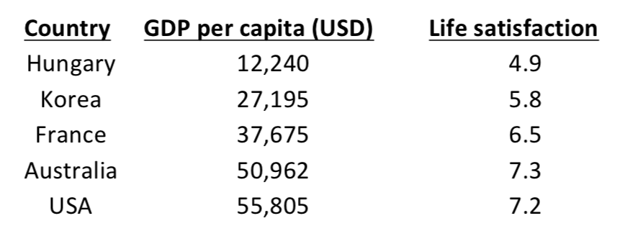

Here is a plot

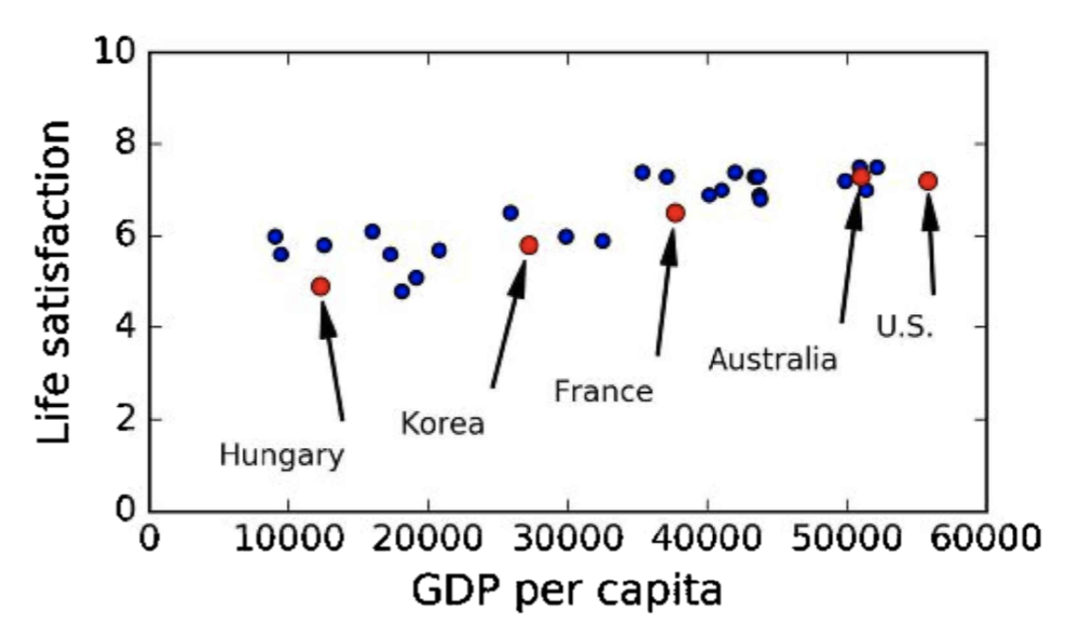

There does seem to be a trend. The data is a little noisy (i.e. partly random) but it mostly looks like life satisfaction goes up more or less linearly as the country’s GDP per capita increases. At this point, you would decide to model life satisfaction as a linear function of GDP per capita. This step is known as model selection.



This model has two parameters, 𝜃0 and 𝜃1. By tweaking these parameters, you can make your model represent any linear function. See below

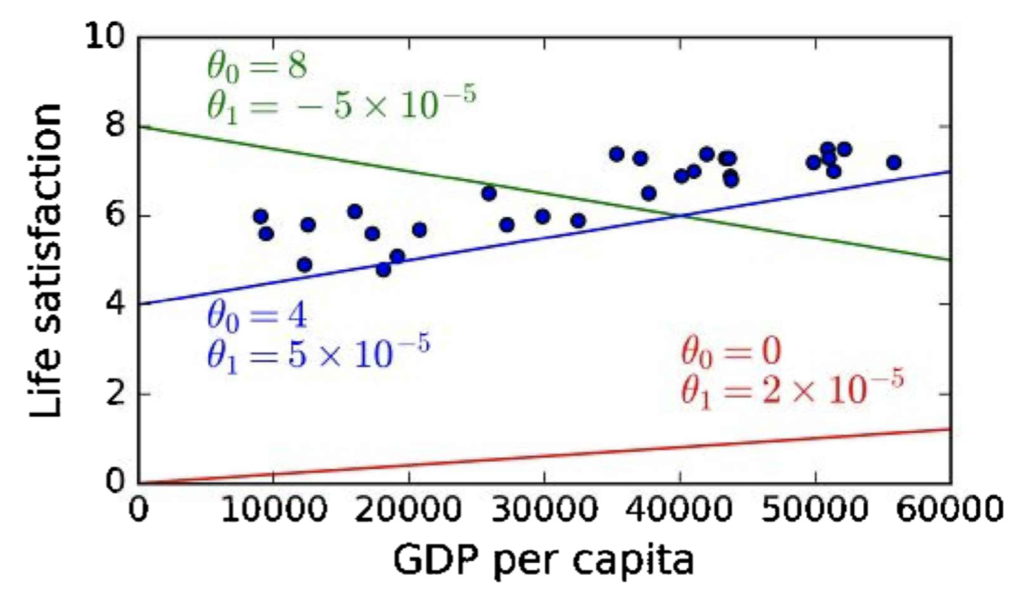

Before you can use your model, you need to define the parameter values 𝜃0 and 𝜃1. How do you know which values will make your model perform best? You need to specify a performance measure. You can either define a fitness function that measures how good your model is, or you can define a cost function that measures how bad it is. For linear regression problems (something we will need to know well), people typically use a cost function that measures the distance between the linear model’s predictions and the training examples where the objective is to minimise this distance.

This is where the Linear Regression algorithm comes in. You feed it your training examples and it finds the parameters that make the linear model fit best to your data. This is called training the model. In this case, the algorithm finds that the optimal parameter values are 𝜃0 = 4.85 and 𝜃1 = 4.91*10(-5).

Now the model fits the training data as closely as possible (for a linear model), see below.

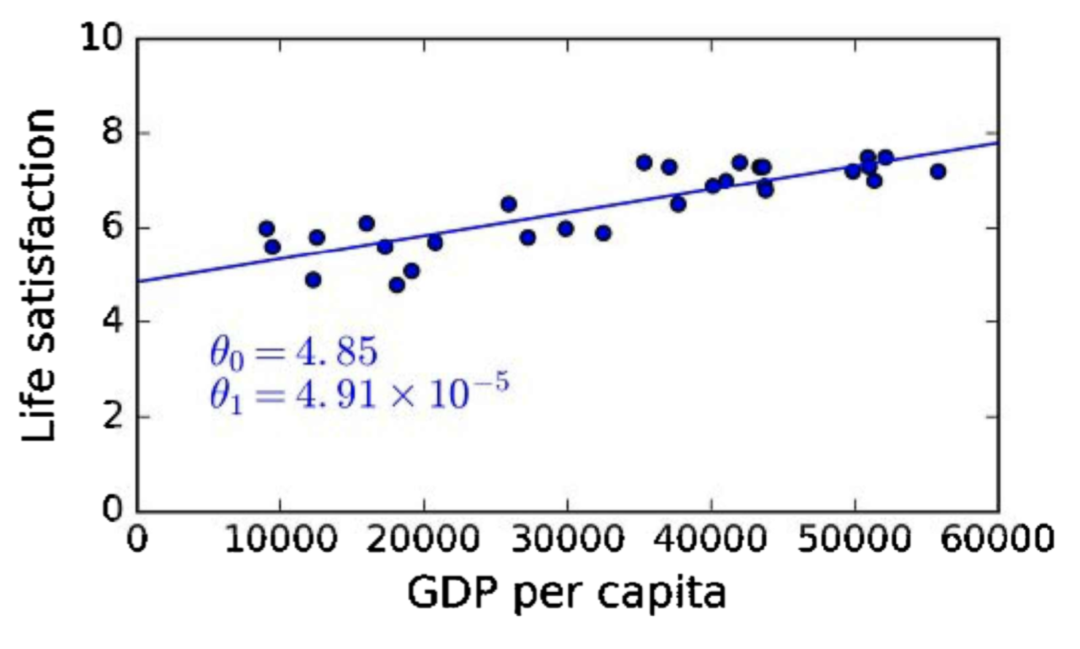

Let’s try this using a Google Colab sheet with a python kernel. We are also going to have to get our own data. This is great for practice for the assignment and will show some degree of complexity in gathering data.

Tools we will use: Google Colab, Git, Excel (or another spreadsheet software), Chrome.

1. Open a web browser and go to the website: stats.oecd.org/index.aspx?DataSetCode=BLI and export the data as a text CSV file with default format to your desktop.

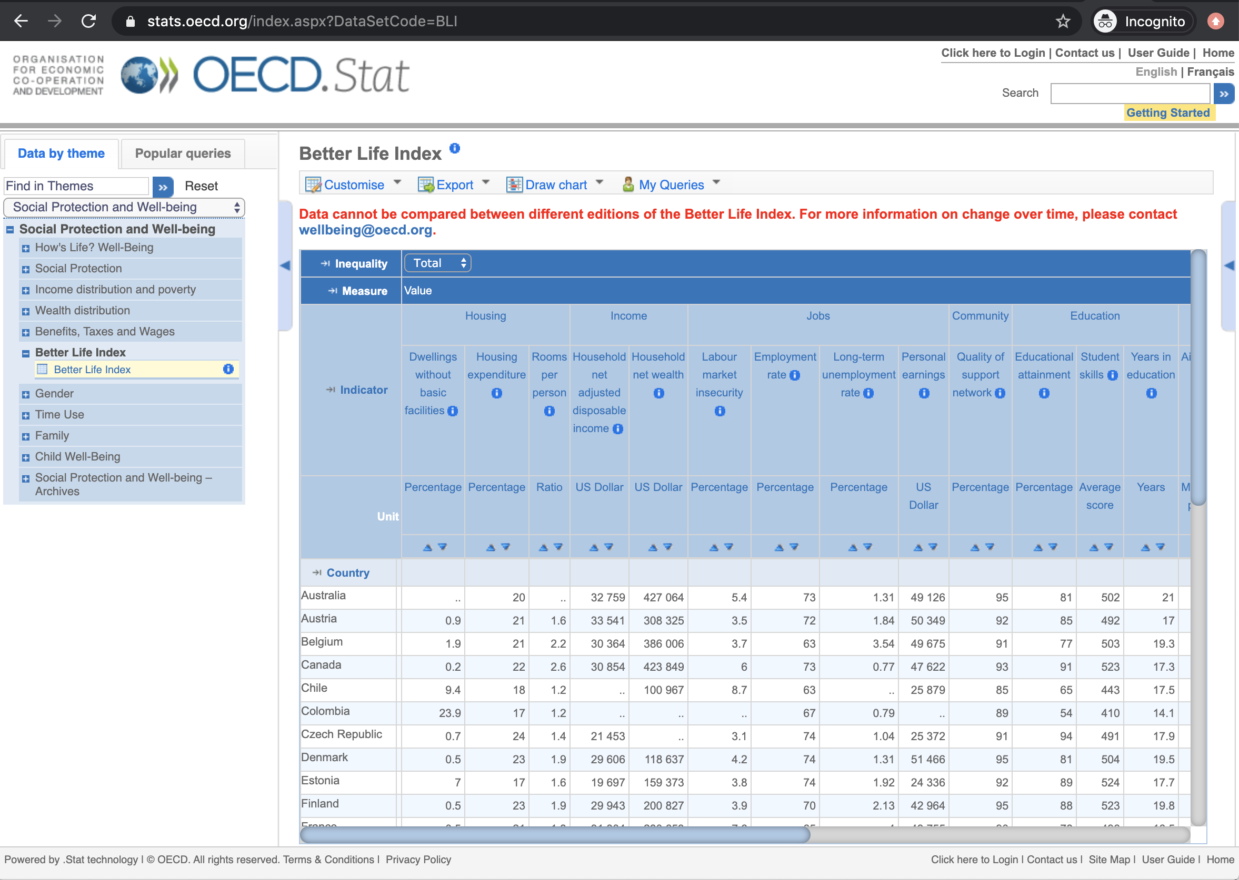

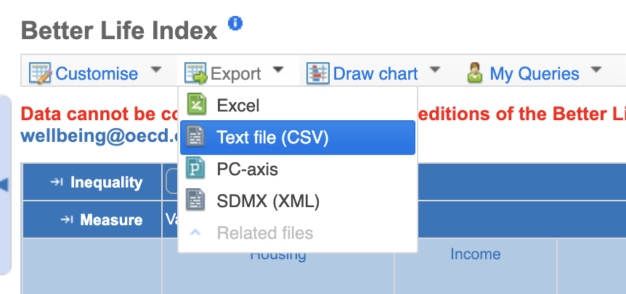

Click Download:

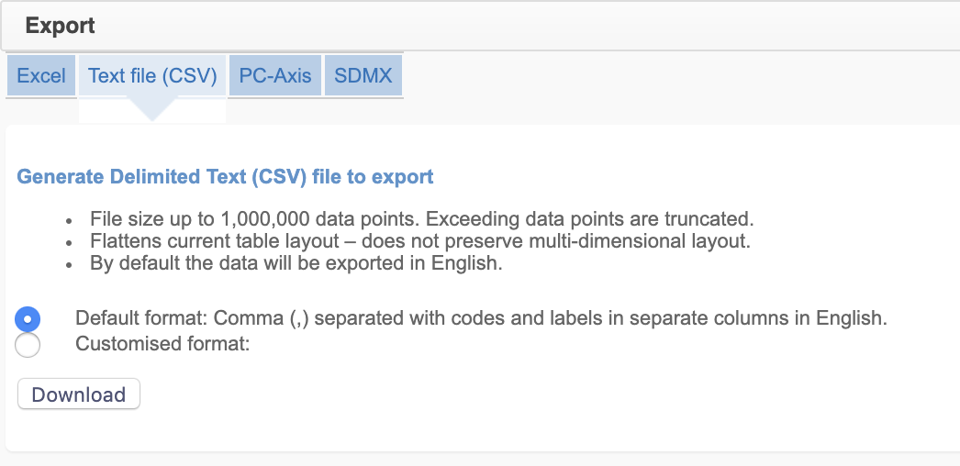

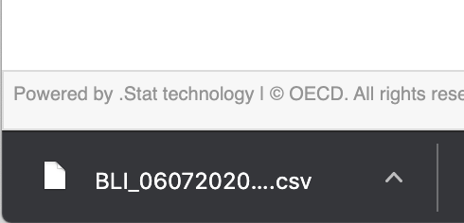

1. Open the file with EXCEL or Libre and we will start by removing everything we don’t need. In column D, find Life Satisfaction and delete every row above and below this, leaving only Life Satisfaction data (DON’T DELETE THE HEADINGS IN ROW 1)

You should now have something like this:

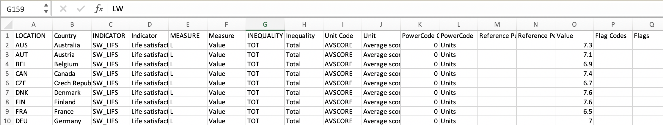

And with a final value like this:

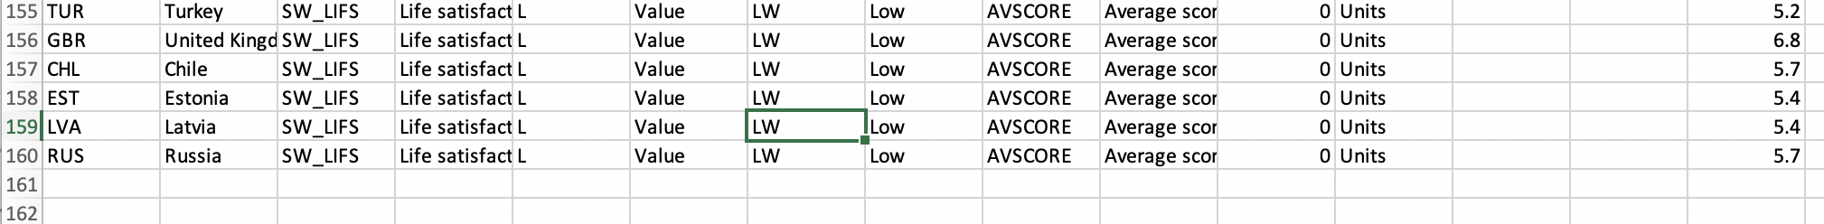

1. Now in column H, there is a heading, inequality, delete all rows that have anything except Total and also the Row with OECD in column A. You should now have the following:

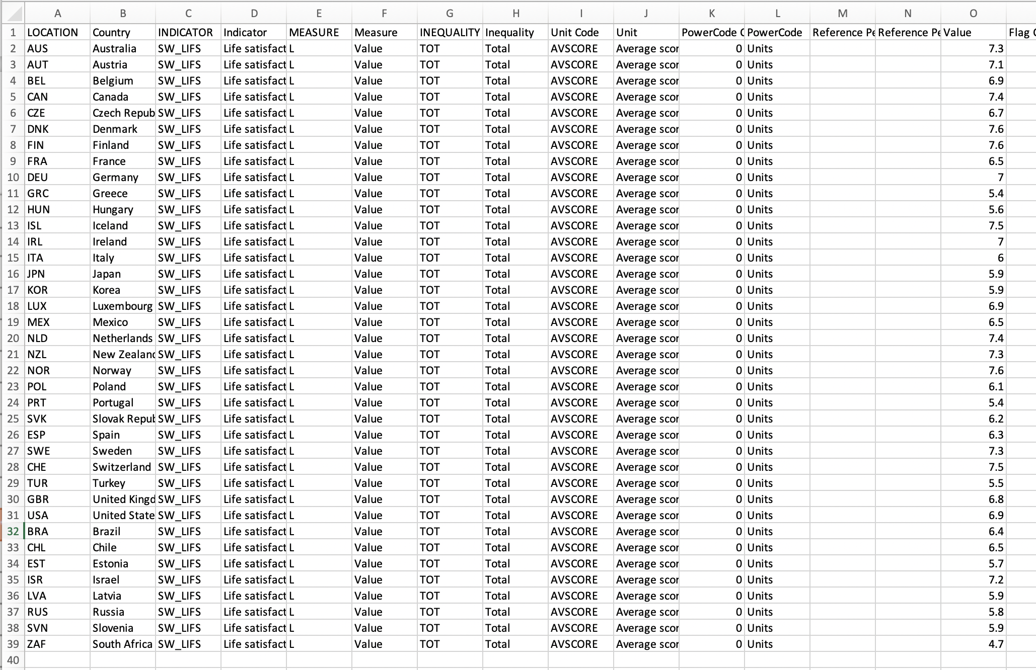

1. Next, Delete all columns except LOCATION, Country and value

You should now have something like this:

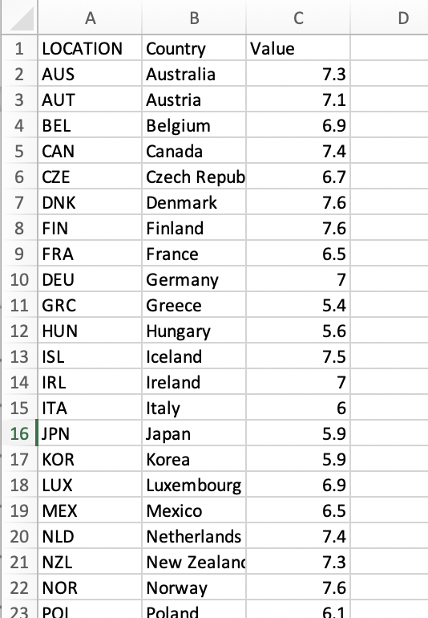

Next, go to the site: <https://data.worldbank.org/indicator/NY.GDP.PCAP.CD?end=2016&start=2015>

You can download this data as a CSV:

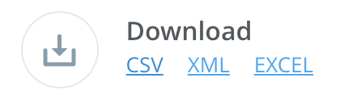

Open the file and copy over the GDP Per Capita values into the existing CSV file with the heading GDPPerCapita in Row 1. This is done manually and is very time consuming:

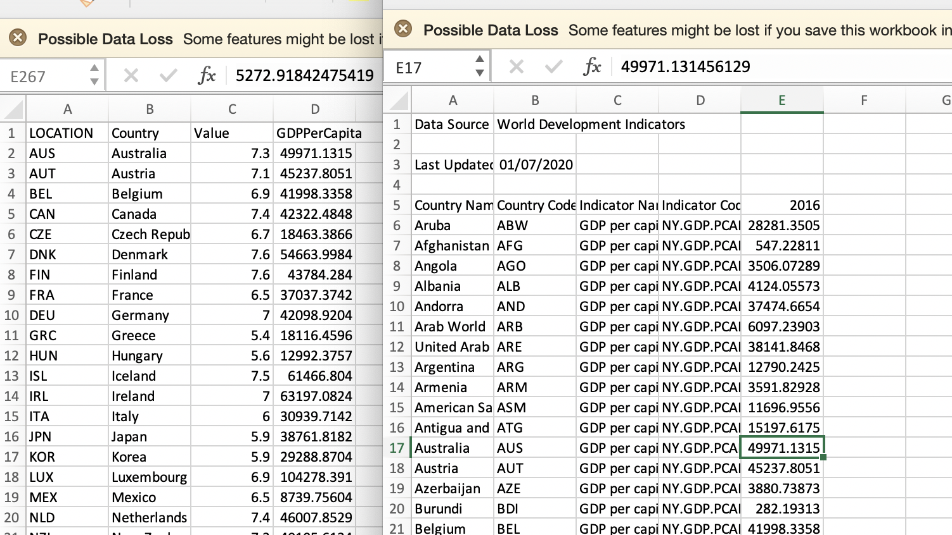

Now we have a data we can use for our Machine Learning task. As you can see this was laborious, even though it was trivial in size. In reality, making data useable is often a very big task:

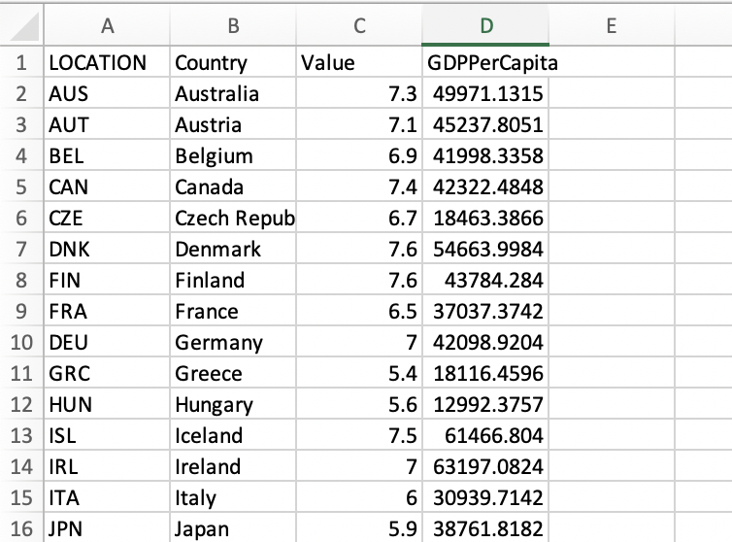

1. If you haven’t already, create a repo in Github. In tutorial 0 you are tasked with making a GitHub account and a repo. You should be signed in:

Go to the URL: <https://github.com/>

On the left-hand column menu, click New:

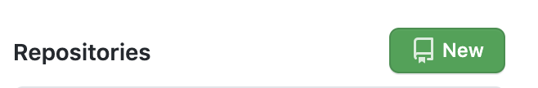

Add a repository name:

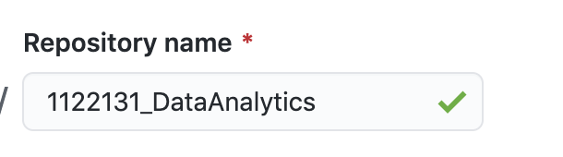

As you can see, I have used my made-up student number, but you should use yours.

Add a description:

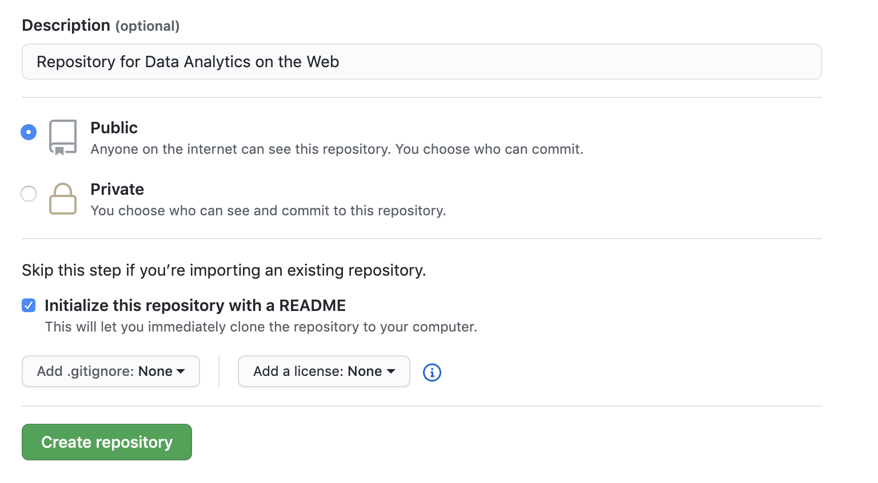

Notice that I have selected “Initialize this repository with a README”.

Click “Create repository”.

You should see something like this:

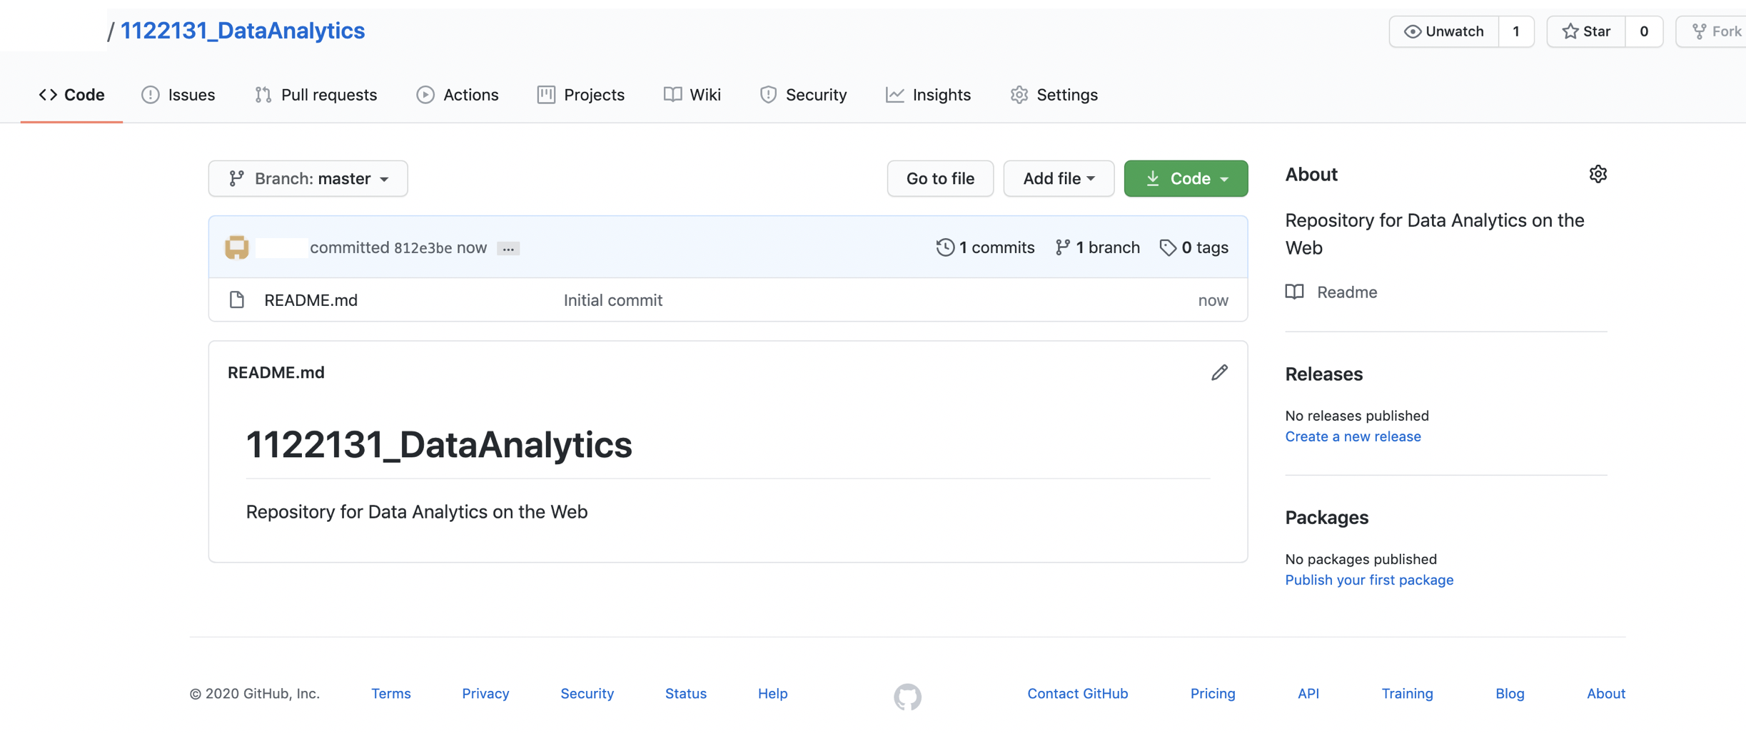

You can add the csv file in a number of different ways but we will just use the web interface. Firstly, save your finished csv file as LifeSatisfactionWorldBankData.csv to somewhere familiar i.e. your Desktop.

On github, on the repo page shown above, click “Add file”:

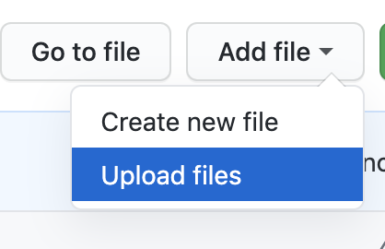

Select the file and write a commit message:

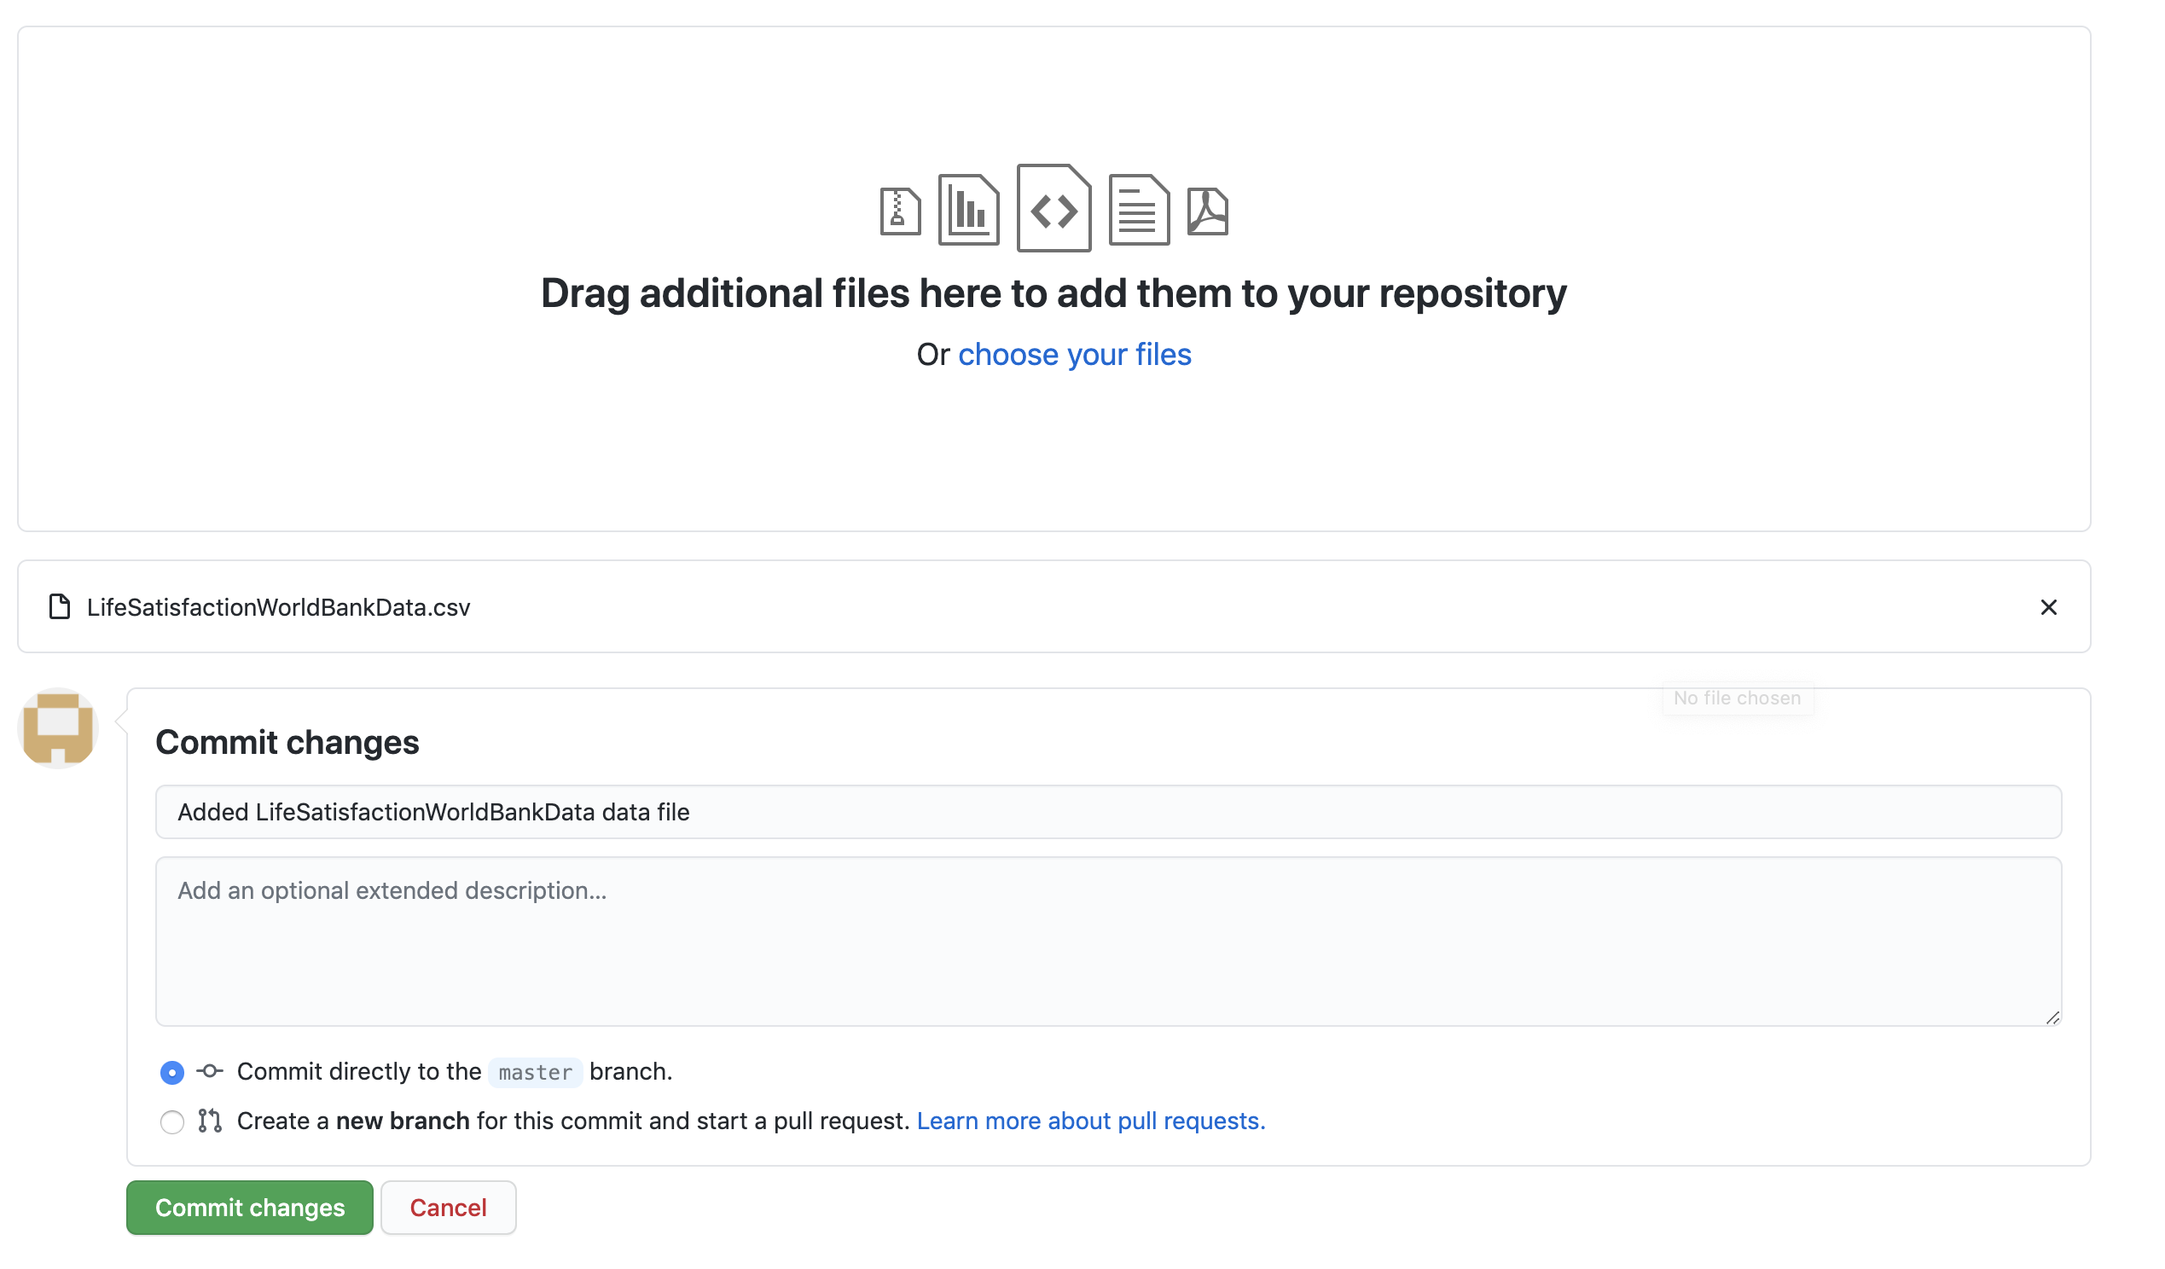

Click “Commit changes”:

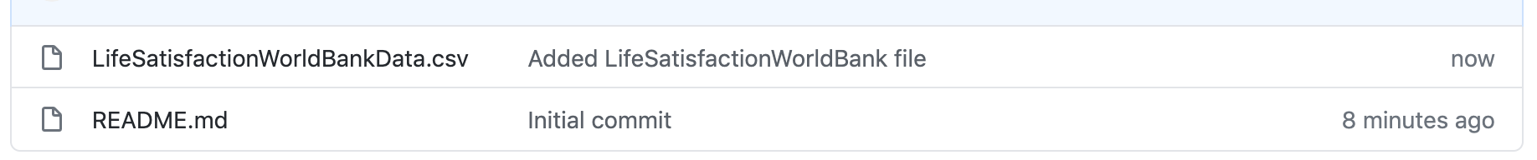

You should now see your file. Click on it:

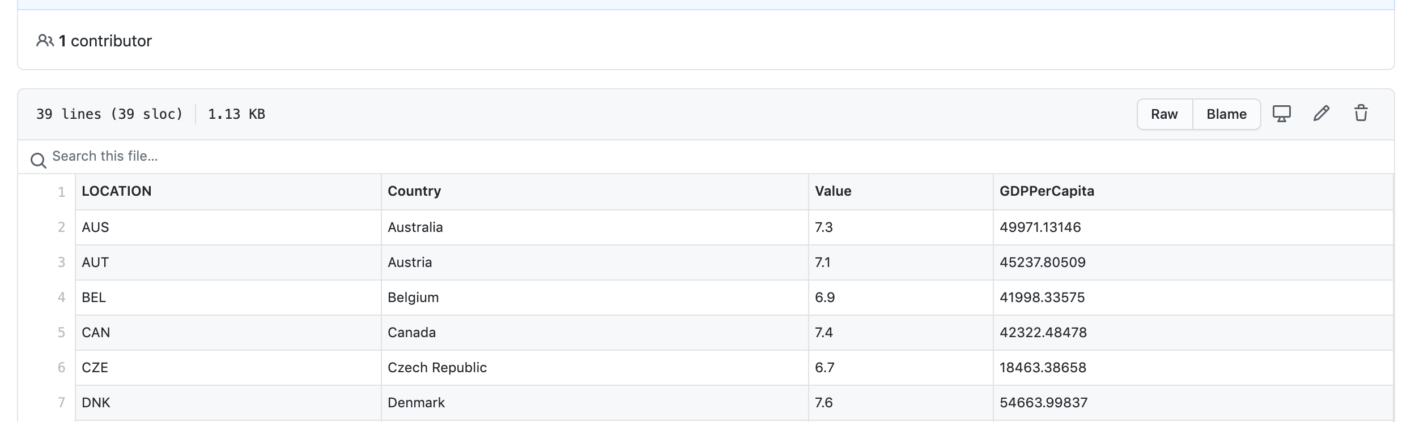

Click on Raw:

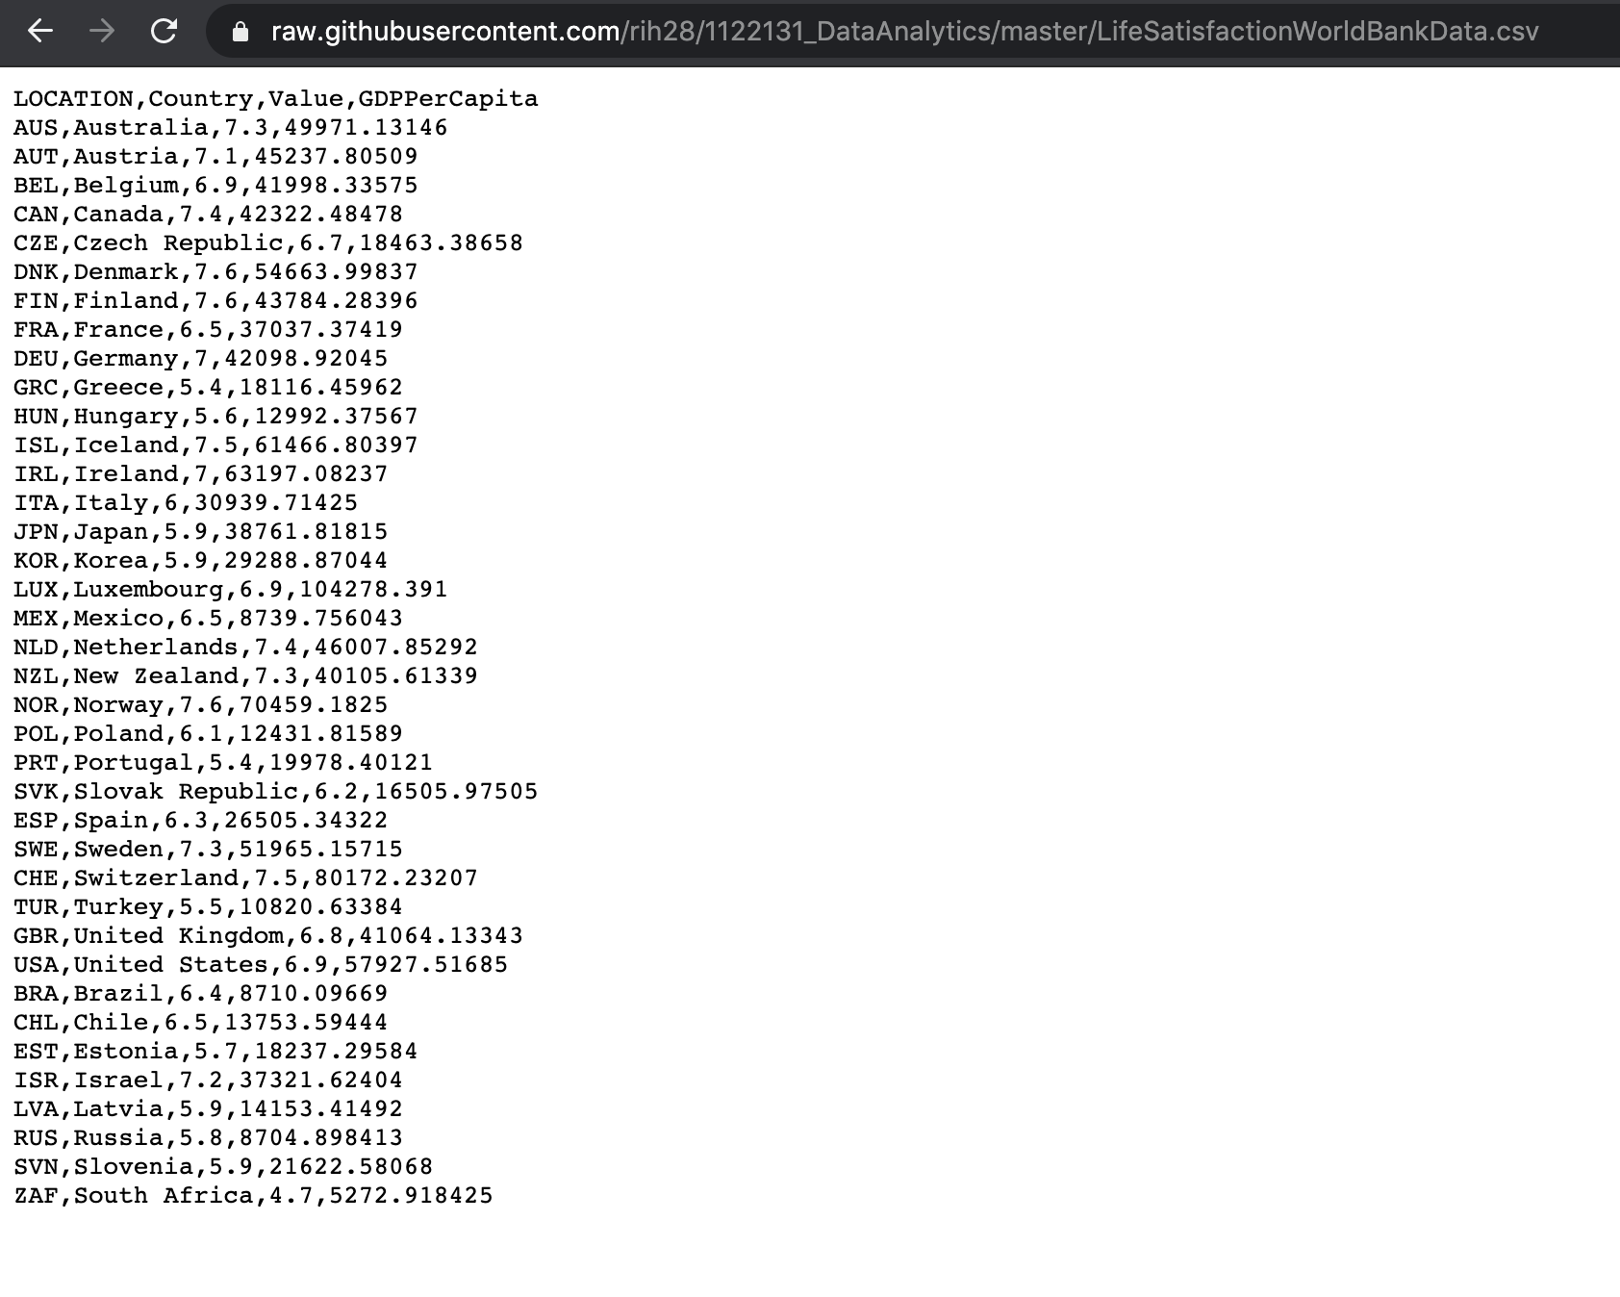

Now, take note of the url, copy it somewhere, we will need it.

1. At this point, I am going to do some investigation with R. Create a new Colab document with an R kernel using this link: <https://colab.research.google.com/notebook#create=true&language=r>

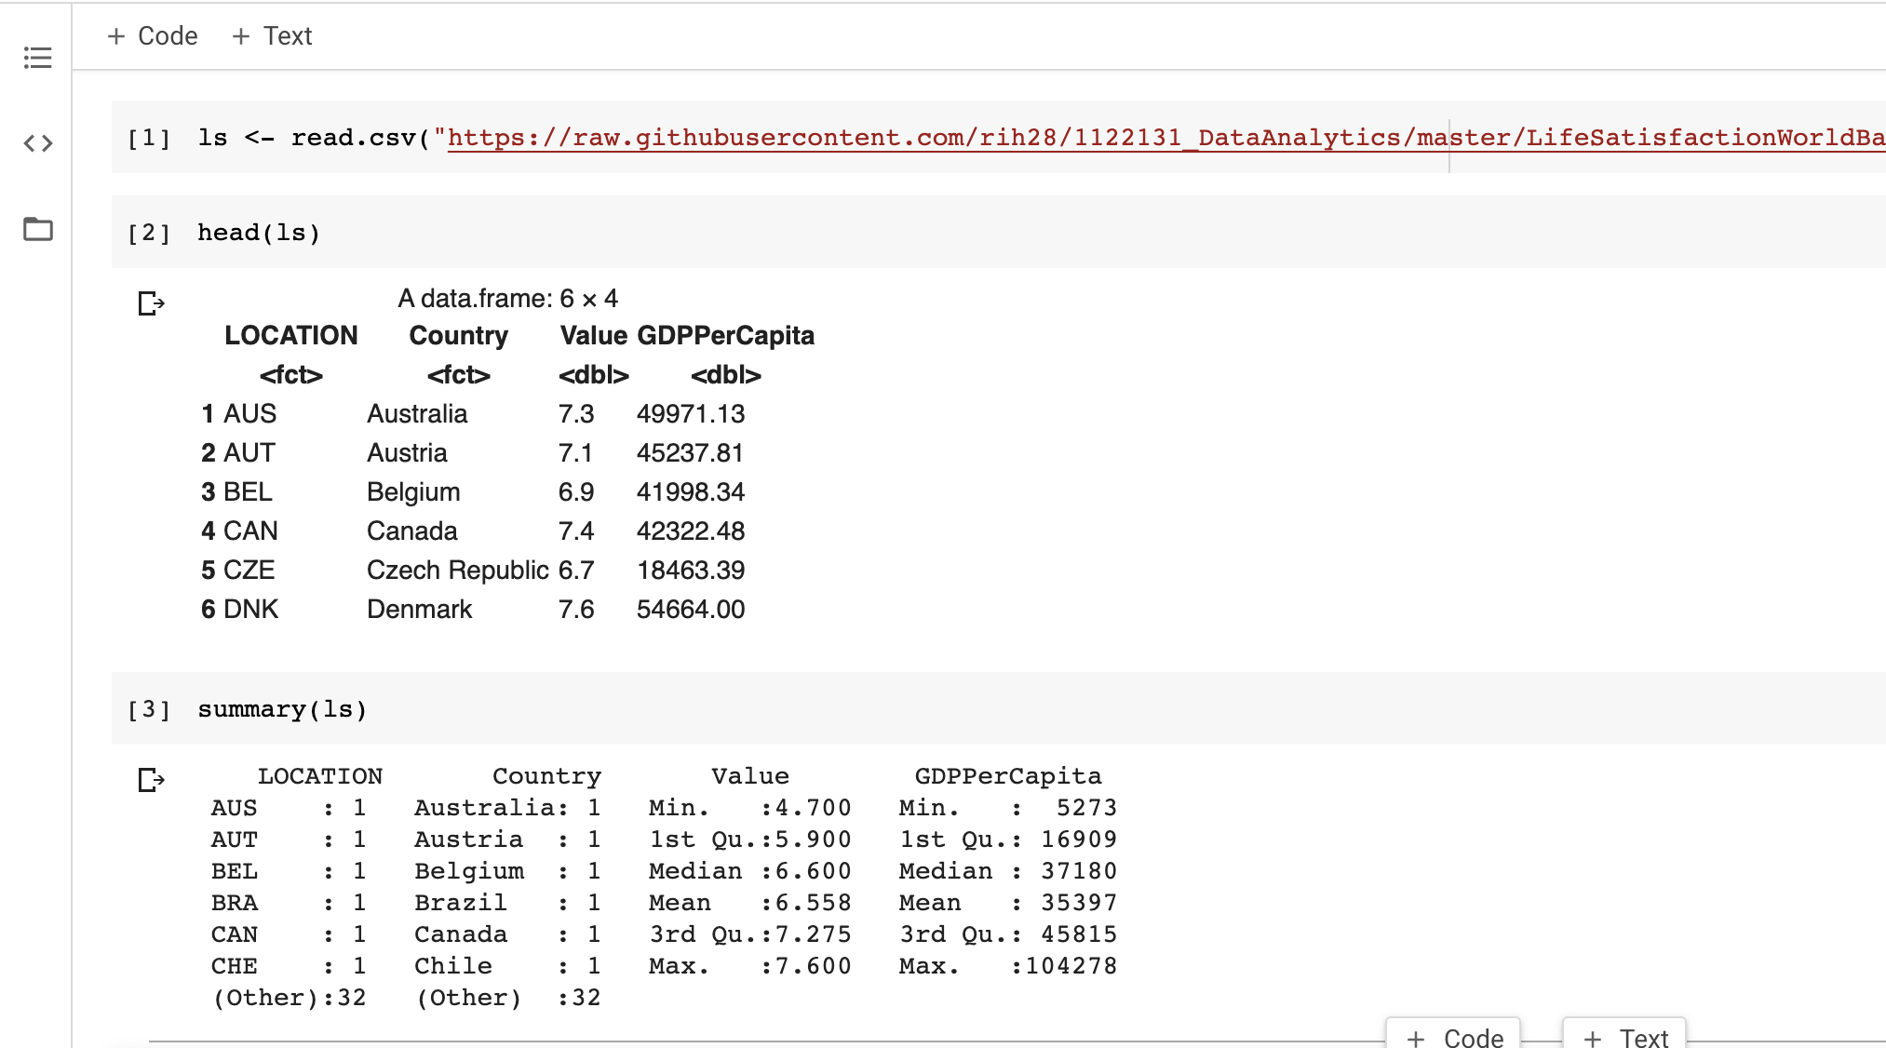

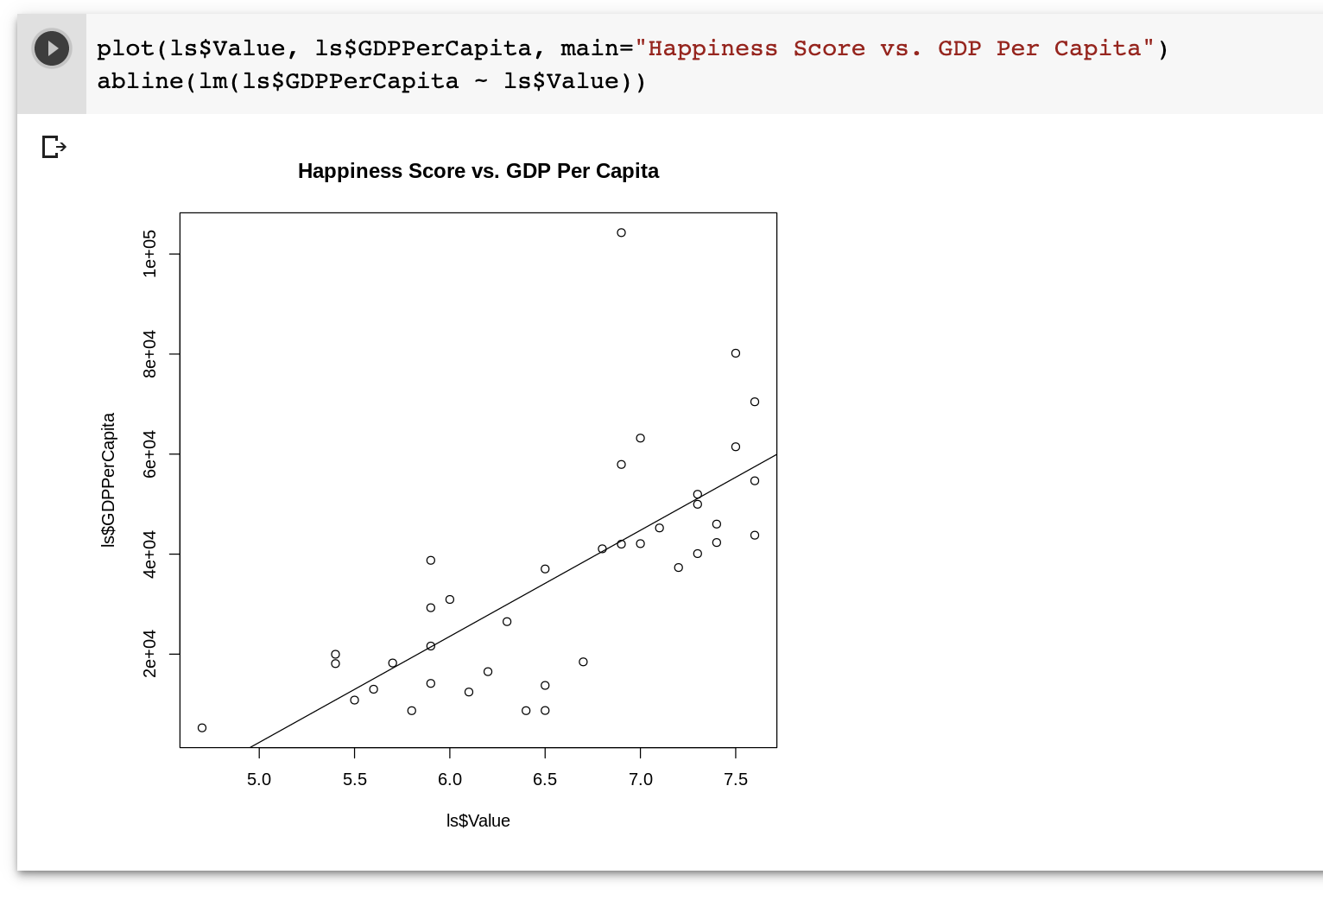

There does appear to be some sort of linear correlation with a few outliers.

Here is a link to the R Kernal Colab sheet above, just in case: <https://github.com/1122131uhi/dataAnalytics/blob/master/part3_3_1_3_2R.ipynb>

So, let’s go for it. Open a new notebook via the GitHub method (as shown earlier) using this link: <https://github.com/1122131uhi/dataAnalytics/blob/master/part3_3_1_3_2a.ipynb>

Now, let’s go back to talking about the earlier model for the same prediction (i.e. the straight line plot). We find that life satisfaction is likely to be somewhere around 4.85 + 22,587 * 4.91 * 10(-5) = 5.96.

Note, if you had used an instance-based algorithm instead, you would have found that Slovenia has the closest GDP per capita to that of Cyprus (20732), and since the OECD data tells us that Slovenians’ life satisfaction is 5.7, you would have predicted a life satisfaction of 5.7 for Cyprus, if you zoom out a bit and look at the two next closest countries, you will find Portugal and Spain with life satisfactions of 5.1 and 6.5, respectively. Averaging these three values, you get 5.77, which is pretty close to the linear regression model. This simple algorithm is called k-Nearest Neighbours regression.

If all went well, your model should make good predictions. If not, you may need to use more attributes (employment rate, health etc.), get more or better quality training data, or perhaps select a more powerful model, for example, a Polynomial Regression Model

3.2 Challenges of Machine Learning

Let’s have a look at what can go wrong with learning and prevent accurate predictions. Our main task is to select a learning algorithm and train it on some data, the two things that can go wrong are using bad algorithm or having bad data.

3.2.1 Bad Data

3.2.1.1 Insufficient Quantity of Training Data

For a child to learn what an orange is, all it takes is for you to point to an orange and say what it is (possibly repeating a few times). Now the child is able to recognise oranges in all sorts of shapes and sizes.

ML is not there yet; it takes a lot of data for most ML algorithms to work properly. Even for very simple problems you typically need thousands of examples, and for complex problems such as image or speech recognition you may need millions of examples.

Many people believe that data is far more important than algorithms. A test has shown that very different ML algorithms perform almost identically well on a complex problem of natural language disambiguation, but data is not easy to come by and to get extra training data is expensive, so we shouldn’t discount algorithms.

3.2.1.2 Non-representative Training Data

In order to generalise well, it is important that your training data be representative of the new cases you want to generalise to. This is true in both instance-based and model-based learning.

For example, the set of countries we used earlier for training the linear model was not perfectly representative i.e. a few countries were missing. Adding in additional countries will change the model drastically and shows that such a simple linear model is probably never going to work well. It seems that very rich countries are not happier than moderately rich countries and some poor countries seem happier than many rich countries. By using a non-representative training set, we trained a model that is unlikely to make accurate predictions, especially for very poor and very rich countries.

It is important to use a training set that is representative of the cases you want to generalise to. This is often harder than it sounds, so, if the sample is too small, you will have sampling noise (i.e. non- representative data as a result of chance), but even very large samples can be non-representative if the sampling method is flawed. This is called sampling bias.

An example of Sampling Bias is taking polls when trying to predict the outcome of elections. In 1936, the Literary Digest conducted a very large poll obtaining 2.4 million responses. They found that the republican presidential candidate would win by 57%, however the democratic candidate won with 62% of the votes. The flaw was in the method, where they sent polls to i.e. magazine subscribers, telephone directories, club memberships etc. In 1936, these tend to favour wealthier people who are more likely to vote Republican. Another flaw was that only 25% of the polls were returned. This is known as nonresponsive bias.

3.2.1.3 Poor-Quality Data

If your training data is full of errors, outliers, and noise, it will make it harder for the system to detect the underlying patterns, so your system is less likely to perform well. It is often well worth the effort

to spend time cleaning up your training data. The truth is, most data scientists spend a significant part of their time doing just that. For example:

-  If some instances are clearly outliers, it may help to simply discard them or try to fix the errors manually

-  If some instances are missing a few features (e.g., 5% of your customers did not specify their age), you must decide whether you want to ignore this attribute altogether, ignore these instances, fill in the missing values (e.g., with median age), or train one model with the feature and one model without it, and so on.

3.2.1.4 Irrelevant Features

Your system will only be capable of learning if the training data contains enough relevant features and not too many irrelevant ones. A critical part of the success of a ML project is coming up with a good set of features to train on. This process is called feature engineering and it involves:

- Feature selection: selecting the most useful features to train on among existing features.

- Feature extraction: combining existing features to produce a more useful one (as we saw earlier, dimensionality reduction algorithms can help)

- Creating new features by gathering new data

3.2.2 Bad Algorithms

3.2.2.1 Overfitting the Training Data

Say you are visiting a foreign country and the taxi driver over charges you. You might be tempted to say that all taxi drivers in that country are thieves. Overgeneralising is something that we humans do all too often, and unfortunately machines can fall into the same trap if we are not careful. In ML this is called overfitting: it means that the model performs well on the training data, but does not generalise well. See below:

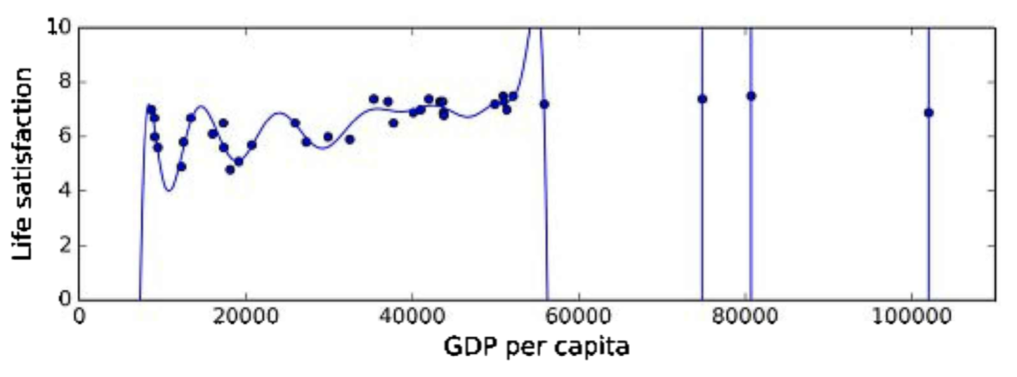

The figure shows an example of a high-degree polynomial life satisfaction model that strongly overfits the training data. Even though if performs much better on the training data than the simple linear model, you would not be able to trust its predications.

Complex models such as deep neural networks can detect subtle patterns in the data, but if the training set is noisy, or if it is too small, then the model is likely to detect patterns in the noise itself. Obviously, these patterns will not generalise to new instances. For example, say you feed your life satisfaction model many more attributes, including uninformative ones such as the country’s name. In that case, a complex model may detect patterns like the fact that all countries in the training data with a w in their name have a life satisfaction greater than 7. This pattern occurred by pure chance and is unlikely to be useful across all countries (i.e. ones that are not in the data set).

Overfitting happens when the model is too complex relative to the amount and noisiness of the training data. The possible solutions are:

-  To simplify the model by selecting one with fewer parameters (e.g. a linear model rather than a high-degree polynomial model), by reducing the number of attributes in the training data or by constraining the model.

-  To gather more training data

-  To reduce the noise in the training data (e.g., fix data errors and remove outliers)

Constraining a model to make it simpler and reduce the risk of overfitting is called regularisation. For example, the linear model we defined earlier has two parameters 𝜃0 and 𝜃1. This gives the algorithm two degrees of freedom to adapt the model to the training data, i.e. it can tweak both the height (𝜃0) and the slope (𝜃1) of the line. If we forced 𝜃1= 0, the algorithm would only have one degree of freedom and would have a much harder time fitting the data properly. For example, all it could do is move the line up or down to get as close as possible to the training instances, so it would end up around the mean. If we allow the algorithm to modify 𝜃1 but we force it to keep it small, then the learning algorithm will effectively have somewhere between one and two degrees of freedom. It will produce a simpler model than with two degrees of freedom, but more complex than just one. You want to find the right balance between fitting the data perfectly and keeping the model simple enough to ensure that it will generalise well.

The amount of regularisation to apply during learning can be controlled by a hyperparameter. A hyperparameter is a parameter of a learning algorithm (not of the model). As such, it is not affected by the learning algorithm itself; it must be set prior to training and remains constant during training. If you set the regularisation hyperparameter to a very large value, you will get an almost flat model (a slope close to zero); the learning algorithm will almost certainly not overfit the training data, but it will be less likely to find a good solution. Tuning hyperparameters is an important part of building a ML system.

3.2.2.2 Underfitting the Training Data

Underfitting is the opposite of overfitting and occurs when your model is too simple to learn the underlying structure of the data. For example, a linear model of life satisfaction is prone to underfit; reality is just more complex than the model, so its predictions are bound to be inaccurate, even on the training examples.

The main options to fix this problem are:

-  Selecting a more powerful model, with more parameters

-  Feeding better features to the learning algorithm (feature engineering)

-  Reducing the constraints on the model (e.g., reducing the regularisation hyperparameter)

3.2.3 Testing and Validating

The only way to know how well a model will generalise to new cases is to try it out on new cases. A good way to do this is to split your data into two sets, the training set and the test set. As these names imply, you train your model using the training set, and you test it using the test set. The error rate on new cases is called the generalisation error (or out-of-sample error), and by evaluating your model on the test set, you get an estimation of this error. This value tells you how well your model will perform on instances it has never seen before.

If the training error is low (i.e. your model makes few mistakes on the training set) but the generalisation error is high, it means that your model is overfitting the training data. It is common to use 80% of the data for training and hold out 20% for testing.

3.2.4 No Free Lunch Theorem

A model is a simplified version of the observations. The simplifications are meant to discard the superfluous details that are unlikely to generalise to new instances. However, to decide what data to discard and what data to keep, you must make assumptions. For example, a linear model assumes that the data is fundamentally linear and that the distance between the instances and the straight line is just noise, which can safely be ignored.

It has been demonstrated that if you make absolutely no assumption about the data, then there is no reason to prefer one model over any other. This is called the No Free Lunch theorem. For some datasets the best model is a linear model, while for other datasets it is a neural network. There is no model that is a priori guaranteed to work better. The only way to know for sure which model is best is to evaluate them all. Since this is not possible, you must instead make some reasonable assumptions about the data and you evaluate only a few reasonable models. For example, for simple tasks you may evaluate linear models with various levels of regularisation, and for a complex problem you may evaluate various neural networks.

**Part 4: A Hands-on approach to Machine Learning**

I need you to imagine that you have been hired by a real estate company to do some data science.

These are the main steps that we will be going through:

6. Look at the big picture  
7. Get the data  
8. Discover and visualise the data to gain insights

9. Prepare the data for Machine Learning algorithms

10. Select a model and train it

Below are some other steps but these are outside the scope of this module, but we will touch on them briefly in the neural networks section:

1. Fine-tune your model
2. Present your solution
3. Launch, monitor and maintain your solution

4.1 Working with real data

When you are learning about Machine Learning (ML) it is best to experiment with real-world data. There are thousands of open datasets ranging across all sorts of domains. We will be using some of them for this section, the tutorials and the assignment.

Here are a few places you can get data:

* -  UC Irvine Machine Learning Repository
* -  Kaggle Datasets
* -  Amazon’s AWS Datasets
* -  http://dataportals.org
* -  http://opendatamonitor.eu
* -  http://quandl.com
* -  Wikipedia’s list of ML datasets

There are others (we will be using some others for a Deep Learning Neural Net Regression task and for the assignment).

Let’s use the California Housing Prices Dataset. By pure coincidence, it is already inside colab! How cool is that? Here is the URL with the R Kernel for the Colab sheet: <https://github.com/1122131uhi/dataAnalytics/blob/master/Part_4_4_1R.ipynb>

Our next step is to train a Deep Neural Network regressor. After this, you will have everything you need to create a Linear Regressor and a Deep Neural Network regressor which is all that you need for the assignment in terms of using Tensorflow. This is the URL for the Colab sheet: <https://github.com/1122131uhi/dataAnalytics/blob/master/Part_4_4_1.ipynb>

**Part 5: Neural Networks**

5.1 Introduction

Nature has influenced many feats of science, birds inspired us to fly for example. It seems only logical to look at the brain’s architecture for inspiration on how to build an intelligent machine. This is the key idea that inspired artificial neural networks (ANNs). Although planes were inspired by birds, they don’t flap their wings. Similarly, ANNs have become quite different from their biological versions. I spent a great deal of my time in academia working in a field that greyed this area further, but that’s for a different course.

ANNs are at the very core of Deep Learning. They are versatile, powerful, and scalable, making them ideal to tackle large and highly complex Machine Learning (ML) tasks, such as classifying billions of images (e.g., Google Images), powering speech recognition services (e.g., Apple’s Siri), recommending the best videos to watch to hundreds of millions of users every day (e.g., YouTube), or learning to beat the world champion at the game of Go by examining millions of past games and then playing against itself (DeepMind’s AlphaGo).

5.2 From Biological to Artificial Neurons

ANNs have been around for quite a while: they were first introduced by McCulloch and Pitts in the 1940s (A paper I remember fondly from my PhD). McCulloch and Pitts presented a simplified computational model of how biological neurons might work together in animal brains to perform complex computations using propositional logic. This was the first artificial neural network architecture. Since then many other architectures have been invented.

The early successes of ANNs until the 1960s led to the widespread belief that we would soon be talking with truly intelligent machines. When it became clear that this promise would go vacant, funding was applied elsewhere and ANNs went out of fashion for a long time. In the 1980s there was a revival of interest in ANNs as new network architectures were invented and better training techniques were developed. But by the 90s, powerful alternative ML techniques such as Support Vector Machines were favoured as they seemed to offer better results and stronger theoretical foundations. We are now in another wave of interest in ANNs (yay I am relevant again!) and it seems that this time, things are a bit different:

- There is now a huge quantity of data available to train neural networks, and ANNs frequently outperform other ML techniques on very large and complex problems.

- The tremendous increase in computing power makes it possible to train large neural networks in a reasonable amount of time. Thanks to the gaming industry and the powerful GPU cards they helped produce.

- The training algorithms have been improved. In truth, there have been only a small amount of tweaks, but these have had a positive impact.

- Some theoretical limitations of ANNs have turned out to be benign in practice. Like getting caught in local minima (which is very rare in practice and if it does, is very close to the global minima)

- ANNs are getting lots of funding and hence progress is being made. Lots of amazing products hit the headlines every other day.

5.3 Biological Neurons

Pretty much what I spent my PhD working on and I am very glad to be back talking (writing) about it. A biological neuron is a cell (see below) found in animal brains, composed of a cell body (which contains most of the cells complex components) and many branching extensions called dendrites (which can be thought of as an “in” connection) and a very long extension called the axon (which can be thought of as an “out” connection). The axons length can be up to tens of thousands of times longer than the cell body. Near the axons end, it splits off into many branches called telodrenia, and at the tip of these branches are synapses, which connect to the dendrites (or cell bodies) of other neurons. Biological neurons receive short electrical impulses called signals from other neurons via synapse. When a neuron receives a sufficient number of signals from other neurons within a few milliseconds, it fires its own signals.

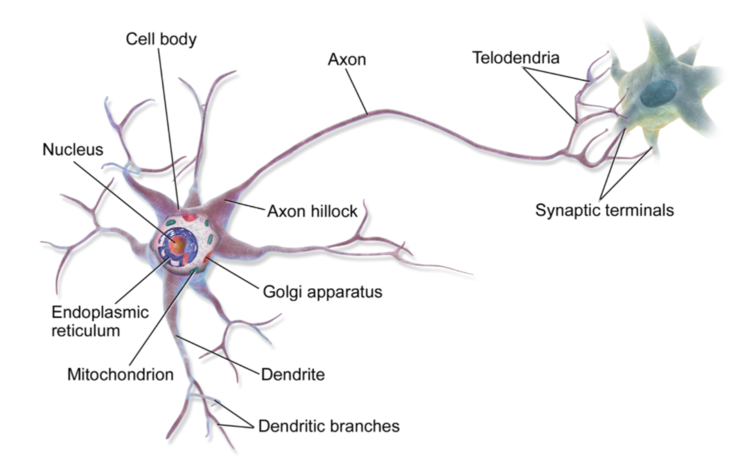

So, it seems, individual neurons seem to behave in a rather simple way, but they are organised in a vast network of billions of neurons, each neuron typically connected to thousands of other neurons. Highly complex computations can be performed by a vast network of fairly simple neurons. The architecture of biological neural networks (BNN) is still the subject of active research, but some parts of the brain have been mapped, and it seems that neurons are often organised in consecutive layers (see below).

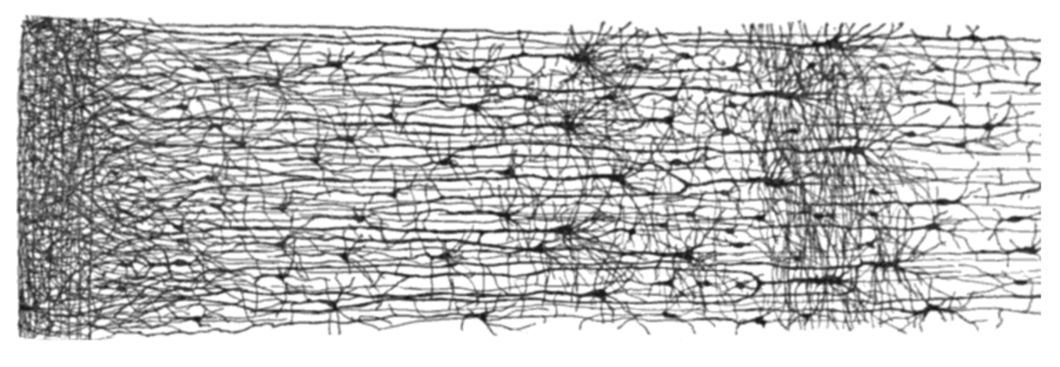

5.4 Logical Computations with Neurons

McCulloch and Pitts proposed a very simple model of the biological neuron, which later became known as an artificial neuron: it has one or more binary inputs and one binary output. The artificial neuron simply activates its output when more than a certain number of its inputs are active. McCulloch and Pitts showed that even with such a simplified model it is possible to build a network of artificial neurons that computes any logical proposition you want. For example, let’s have a look at some ANNs that perform various logical computations assuming that a neuron is activated when at least two of its inputs are active.

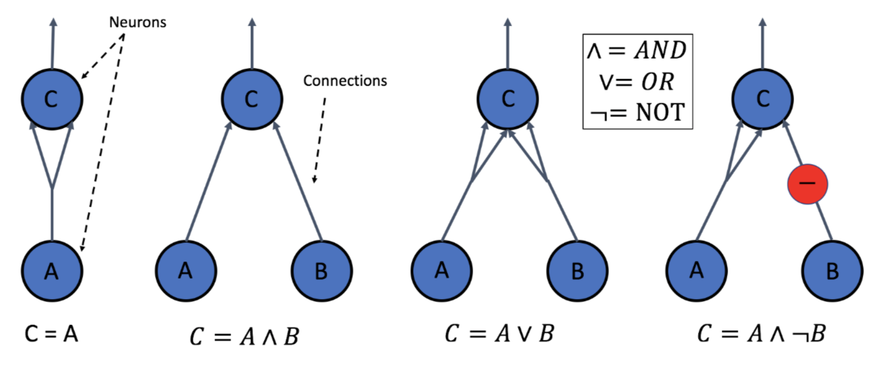

-  The first network on the left is simply the identity function: if neuron A is activated, then neuron C gets activated as well (since it receives two input signals from neuron A), but if neuron A is off, then neuron C is off as well.

-  The second network performs a logical AND: neuron C is activated only when both neurons A and B are activated (a single input signal is not enough to activate neuron C).

-  The third network performs a logical OR: neuron C is activated if either neuron A or neuron B is activated (or both).

-  Next, if we suppose that an input connection can inhibit the neurons activity (which is the case with biological neurons), then the fourth network computes a slightly more complex logical proposition: neuron C is activated only if neuron A is active and if neuron B is off. If neuron A is active all the time, then you get a logical NOT: neuron C is active when neuron B is off, and vice, versa.

It is clear to see how these types of networks can be combined to compute complex logical expressions.

5.5 The Perceptron

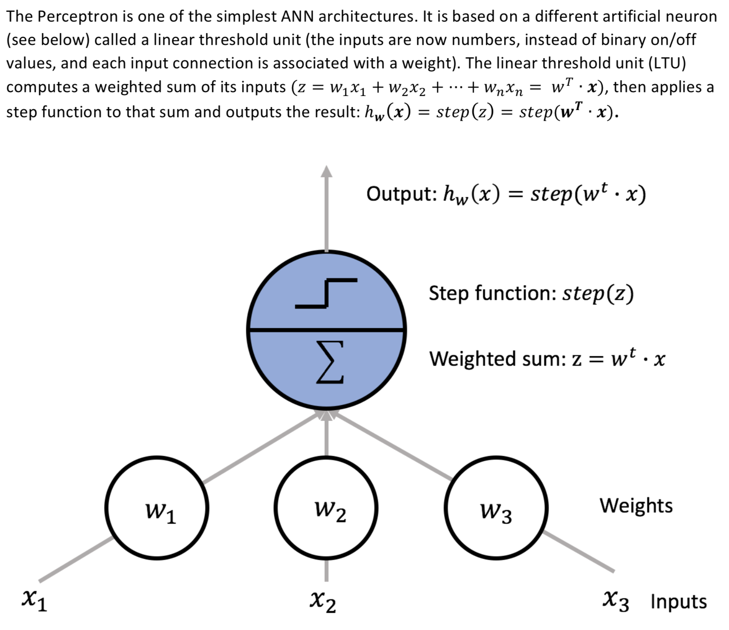

The most common step function used in Perceptrons is the Heaviside step function.

A single LTU can be used for simple linear binary classification. It computes a linear combination of the inputs and if the result exceeds a threshold, it outputs the positive class or else outputs the negative class. For example, you could use a single LTU to classify iris flowers based on the petal length and width. Training an LTU means finding the right values for w0, w1 and w2.

A perceptron is simply composed of a single layer of LTUs, with each neuron connected to all the inputs. These connections are often represented using special passthrough neurons called input neurons (they just output whatever input they are fed). An extra bias feature is generally added (x0 = 1). This bias feature is typically represented using a special type of neuron called a bias neuron, which just outputs 1 all the time.

A Perceptron with two inputs and three outputs (shown below) can classify instances simultaneously into three different binary classes, which makes it a multi-output classifier.

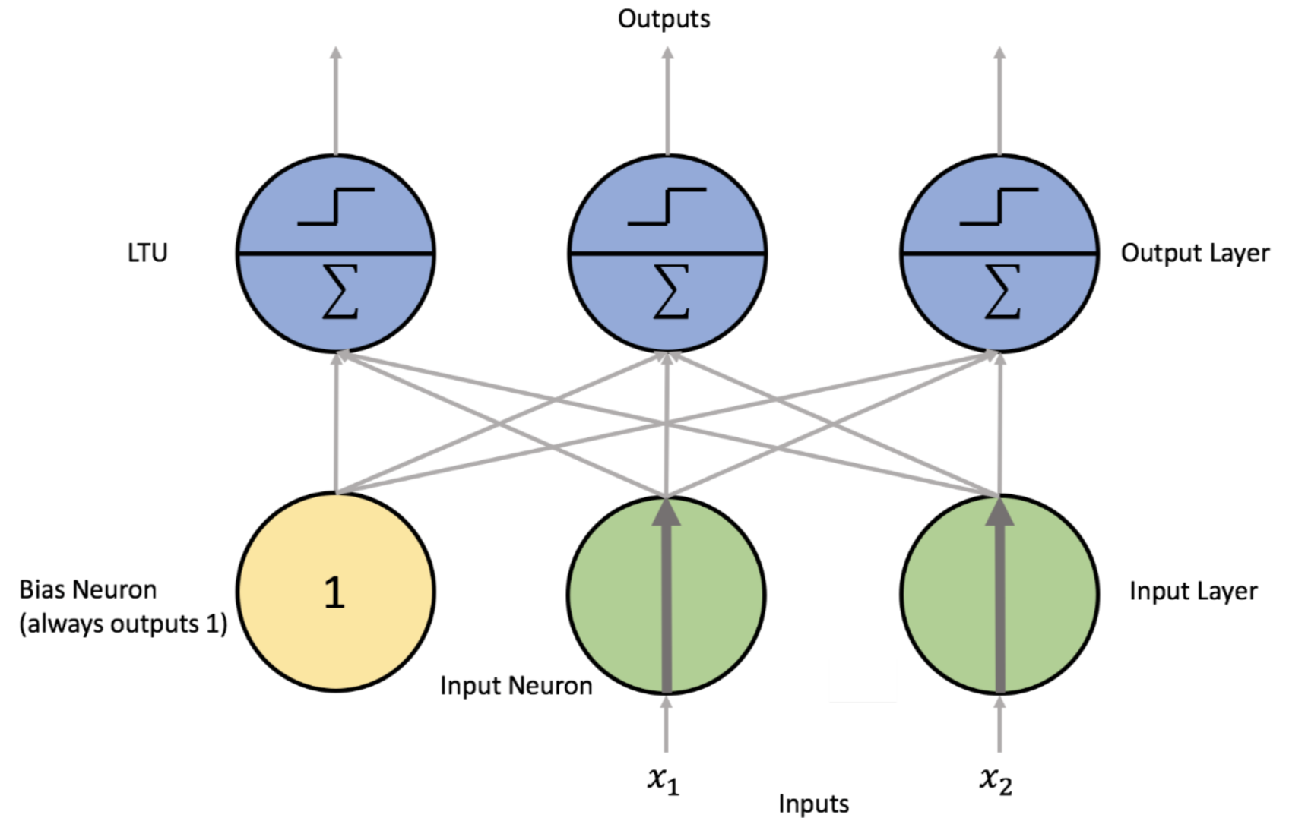

A Perceptron is trained using a training algorithm that was inspired Hebb’s rule. Hebb suggested that when a biological neuron triggers another neuron often, the connection between these two neurons grows stronger. This is often called Hebbian Learning; that is, the connection weight between two neurons is increased whenever they have the same output. Perceptrons are trained using a variant of this rule that takes into account the error made by the network; it does not reinforce connections that lead to the wrong output. More specifically, the Perceptron is fed one training instance at a time, and for each instance it makes its predications. For every output neuron that produced a wrong prediction, it reinforces the connection weights from the inputs that would have contributed to the correct prediction.

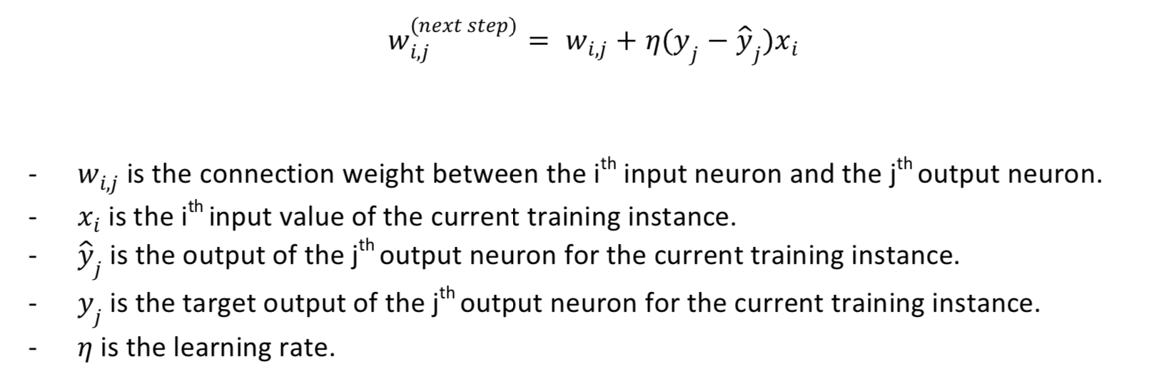

The decision boundary of each output neuron is linear, so Perceptrons are incapable of learning complex patterns. However, if the training instances are linearly separable, it has been demonstrated that this algorithm would converge to a solution. This is called the Perceptron convergence theorem.

Perceptrons don’t output a class probability; rather, they just make predictions based on a hard threshold. This is one of the good reasons to prefer Logistic Regression over Perceptrons.

It has been shown that Perceptrons have a number of weaknesses, in particular that they are incapable of solving trivial problems (i.e. XOR). Of course, this is true of any linear classification model (as well as Logistic Regression classifiers). However, it turns out that some of the limitations of Perceptrons can be eliminated by stacking multiple Perceptrons. The resulting ANN is called a Multi- Layer Perceptron (or an MLP). In particular, an MLP can solve the XOR problem (see the image below) where for each combination of inputs, with inputs (0, 0) or (1, 1) the network outputs 0, and with inputs (0, 1) or (1, 0) it outputs 1.

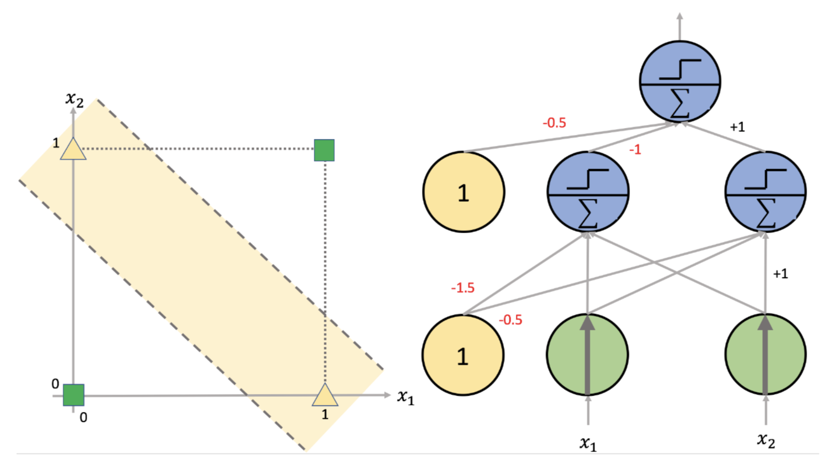

5.6 Multi-Layer Perceptron and Backpropogation

An MLP is composed of one input layer, one or more layers of LTUs, called hidden layers, and one final layer of LTUs called the output layer (see below).

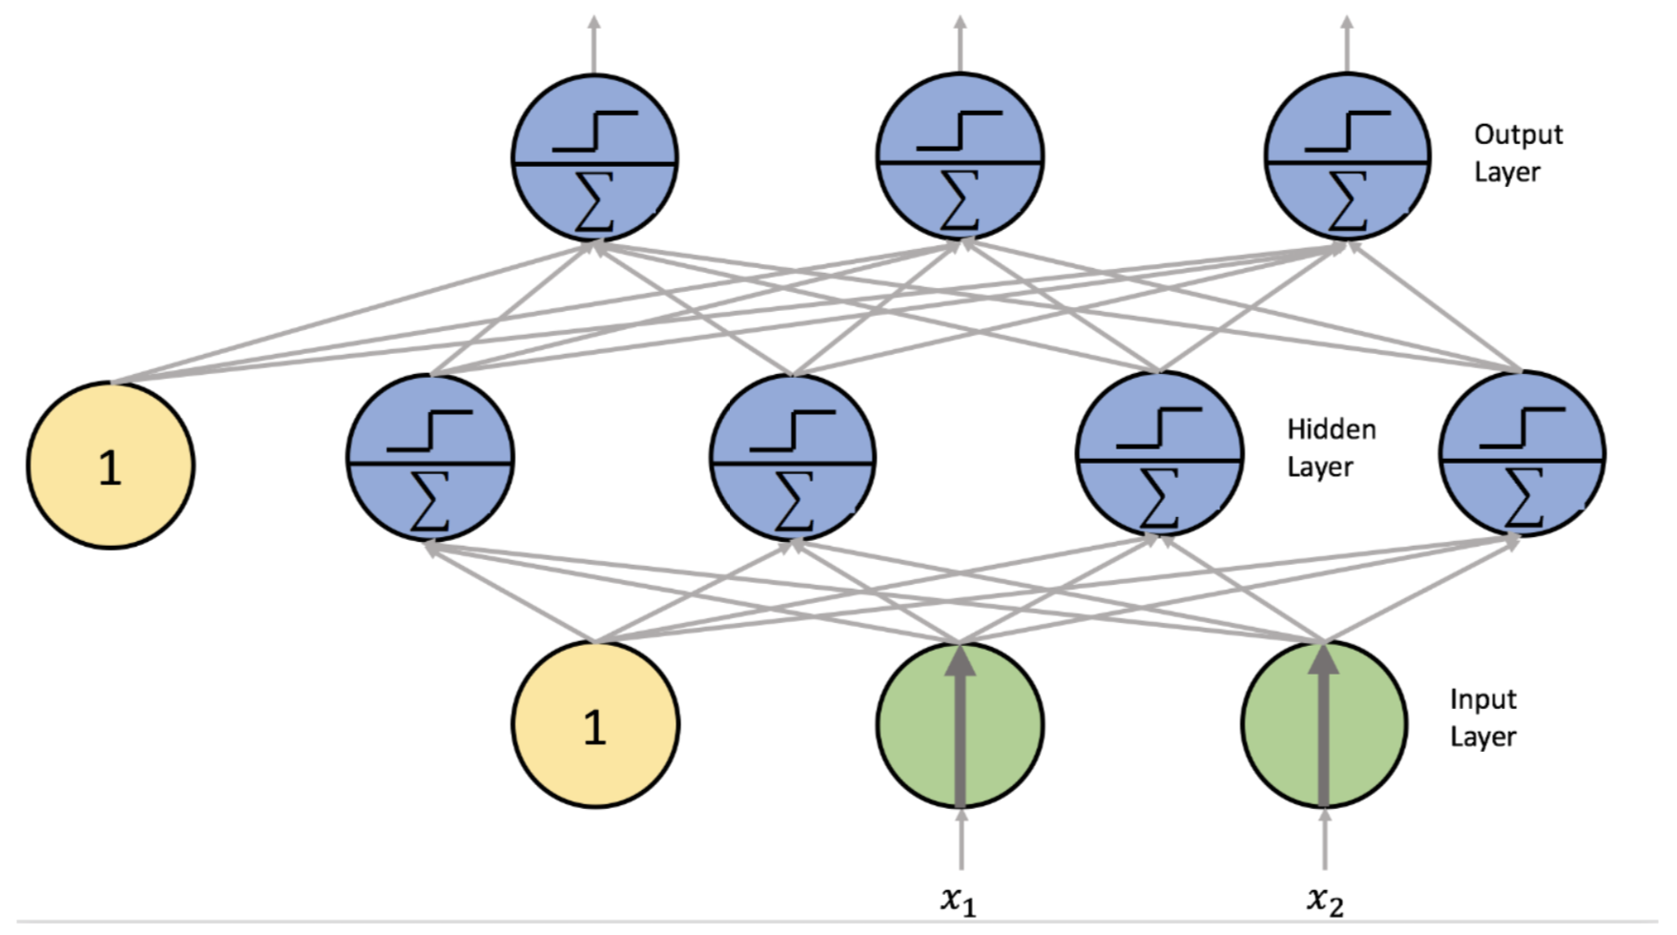

Every layer except the output layer includes a bias neuron and is fully connected to the next layer. When an ANN has two or more hidden layers, it is called a deep neural network (DNN).

A method of training an MLP is known as the backpropagation training algorithm. It is also known as Gradient Descent. For each training instance, the algorithm feeds it to the network and computes the output of every neuron in each consecutive layer, just like making predictions. Then it measures the network’s output error, the difference between the desired output and the actual output of the network, and it computes how much each neuron in the last hidden layer contributed to each output neuron’s error.

It then proceeds to measure how much of these error contributions came from each neuron in the previous hidden layer, and so on until the algorithm reaches the input layer. The reverse pass efficiently measures the error gradient across all the connection weights in the network by propagating the error gradient backward in the network. The last step of the backpropagation algorithm is a Gradient Descent step on all the connection weights in the network, using the error gradients measured earlier.

In order to make this work, the step function was replaced with a logistic function. This is important as the step function has no gradient, while the logistic function has a well-defined nonzero derivative everywhere, allowing Gradient Descent to make some progress at every step. There are other activation functions such as hyperbolic tangent and ReLU.

An MLP is often used for classification, with each output corresponding to a different binary class, for example spam/non-spam emails.

Here is an example of the MNIST classification problem using tensorflow. We will not be using a classification task for the assignment (or for much in the course) but it will give you some practice and insight to using TensorFlow;

Here is the easy tutorial:

https://www.tensorflow.org/get_started/mnist/beginners

Here is the more in-depth one:

https://www.tensorflow.org/get_started/mnist/pros

**Note: At this point we would normally build and train the neural network, then use it. However, let us go through some further points for consideration.**

5.7 Fine-Tuning Neural Network Hyperparameters

The flexibility of neural networks is also one of their main drawbacks, there are many hyperparameters to tweak. Just think of the endless configurations (Recurrent networks, convolutional networks etc.) and even MLPs can change the number of layers, the number of neurons per layer, the type of activation function used in each layer, weight initialisation logic and so on. How do we know what combination of hyperparameters is best for our task?

It is very tough! Let’s look at the number of hidden layers:

You can model any complex function with only one hidden layers, as long as you have enough neurons. However, shallow networks like this have a lower parameter efficiency, so, deep nets can model complex functions using exponentially fewer neurons and thus, making them much faster to train.

The DNNs hierarchical architecture helps them converge faster to a good solution and it also improves their ability to generalise to new datasets.

So, for many problems you can start with just one or two hidden layers and it will work very well. For more complex problems, you can gradually ramp up the number of hidden layers, until you start overfitting the training set. Large image classification tasks or speech recognition tasks require networks with dozens of layers and they need a huge amount of training data.

Next, let’s look at the number of neurons per hidden layer:

The number of neurons in the input and output layer is determined by the type of input and output the task requires. In the MNIST problem, input layer has 784 neurons and 10 output neurons. It is common practice to size them to form a funnel, with fewer and fewer neurons at each layer. The reason for this is that many low-level features coalesce into far fewer high-level features. However, this method is outdated and it is common practice to have all hidden layers with the same size. To make things work via tuning, just increase the number of neurons until the network starts overfitting. It is better to increase the number of layers rather than the number of neurons. Finding the perfect number of neurons is a bit of a dark art rather than a cold hard process.

There are many more things to learn about in terms of Deep Learning Neural Networks and other Machine Learning techniques, but this is unfortunately outside the scope of this course. I encourage you to try out some of the tutorials on TensorFlow and maybe play around with it and some real data once you finish this course.

Here is some supplementary youtube videos to help give some extra information:

https://www.youtube.com/watch?v=BR9h47Jtqyw https://www.youtube.com/watch?v=1L0TKZQcUtA

**Tutorial Set**

Here you will be able to watch a sequence of short videos that will help you work towards the assignment and will help supplement what you have learned so far in a more practical way.

Case study:

You have been hired by a NYC Taxi firm to create a model that can predict the demand for taxi’s on a particular day of the week. During the scoping part of this project, you have been told that weather is an important factor and in particular, rainfall and temperature.

Tutorial 0 – Getting set-up

Tutorial 1 – Get the data

Tutorial 2 – Data Analysis with R

Tutorial 3 – Linear Regression with Tensorflow

Tutorial 4 – Deep Learning Neural Network Regression with Tensorflow

**Appendix A**

This checklist is designed to guide you through Machine Learning Projects: Frame the Problem and Look at the Big Picture

1. Define the objective in business terms.
2. How will your solution be used?
3. What are the current solutions/methods (there may not be any)?
4. How should you frame this problem (supervised/unsupervised, online/offline, etc.)?
5. How should performance be measured?
6. Is the performance measure aligned with the business objective?
7. What would be the minimum performance needed to reach the business objective?
8. What are comparable problems? Can you reuse experience or tools?
9. Is human expertise available?
10. How would you solve the problem manually?
11. List the assumptions you (or other people) have made so far.
12. Verify assumptions if possible.

Get the Data

1. List the data you need and how much you need.
2. Find and document where you can get that data.
3. Check how much space it will take.
4. Check legal obligations and get authorisation if necessary.
5. Get access authorisations.
6. Create a workspace.
7. Get the data.
8. Convert the data to a format you can easily manipulate.
9. Ensure sensitive information is deleted or protected (anonymise)
10. Check the size and type of data (time series, sample, geographical, etc.)
11. Sample a test set, put it aside, and never look at it.

Explore the Data

1. Create a copy of the data for exploration
2. Remember to keep a record of your data exploration
3. Study each attribute and its characteristics:
4. For supervised learning tasks, identify the target attribute(s)

-  Name

-  Type (text, int/float, text, structured, etc.)

-  % of missing values

-  Noisiness and type of noise (stochastic, outliers, rounding errors, etc.)

-  Possibly useful for task?

-  Type of distribution (Gaussian, uniform, logarithmic, etc.)

1. Visualise the data
2. Study the correlations between attributes
3. Study how you would solve the problem manually
4. Identify the promising transformations you may want to apply
5. Identify extra data that would be useful i.e. go back to Get the Data
6. Document what you have found/learned

Prepare the Data

Notes:

-  Work on copies of the data (i.e. keep the original dataset intact)

-  Write functions for all data transformations you apply (i.e. so you can easily prepare the data next time you get a fresh dataset, so you can apply these transformations in other projects, to clean and prepare the test set, to clean and prepare new data instances once your solution is live, to make it easy to treat your preparation choices as hyperparameters)

1. Data Cleaning

-  Fix or remove outliers

-  Fill in missing values (e.g., with zero, mean, median...) or drop their rows (or columns)

2. Feature selection  
- Drop the attributes that provide no useful information for the task.

3. Feature engineering

-  Discretise continuous features

-  Decompose features (categorical, date/time, etc.).

-  Add promising transformations of features (e.g., log(x), sqrt(x), x^2, etc.).

-  Aggregate features into promising new features

4. Feature scaling: standardise or normalise features.

Short-list Promising Models

-  If the data is huge, you may want to sample smaller training sets so you can train many different models in a reasonable time

-  Try to automise these steps as much possible

1. Train many quick and dirty models from different categories (e.g., linear, naive Bayes, SVM, Random Forests, neural net, etc.) Using standard parameters.
2. Measure and compare their performance.

- For each model, use N-fold cross-validation and compute the mean and standard deviation of the performance measure on the N folds.

1. Analyse the most significant variables for each algorithm
2. Analyse the types of errors the models make

- What data would a human have used to avoid these errors?

1. Have a quick round of feature selection and engineering
2. Have one or two more quick iterations of the five previous steps.

7. Short-list the top three to five most promising models, preferring models that make different types of errors.

Fine-Tune the System

-  You will want to use as much data as possible here, especially as you move toward the end of fine-tuning.

-  As always automate what you can.

1. Fine-tune the hyperparameters using cross-validation.
2. Try Ensemble methods.
3. Once you are confident about your final model, measure its performance on the test set to estimate the generalisation error.

Present Your Solution

1. Document what you have done.
2. Explain why your solution achieves the business objective.
3. Don’t forget to present interesting points you found

-  Describe what worked and what didn’t

-  List your assumptions and your systems limitations

4. Ensure your key findings are communicated through beautiful visualisations or easy-to-remember statements (e.g., “the median income is the number-one predictor of housing prices”).

Launch